PART 1: Deploying EC2 instances (Change Region to US East (Ohio) us-east-2)

TASK 1: Start by creating a new user with following permissions and log in using that.

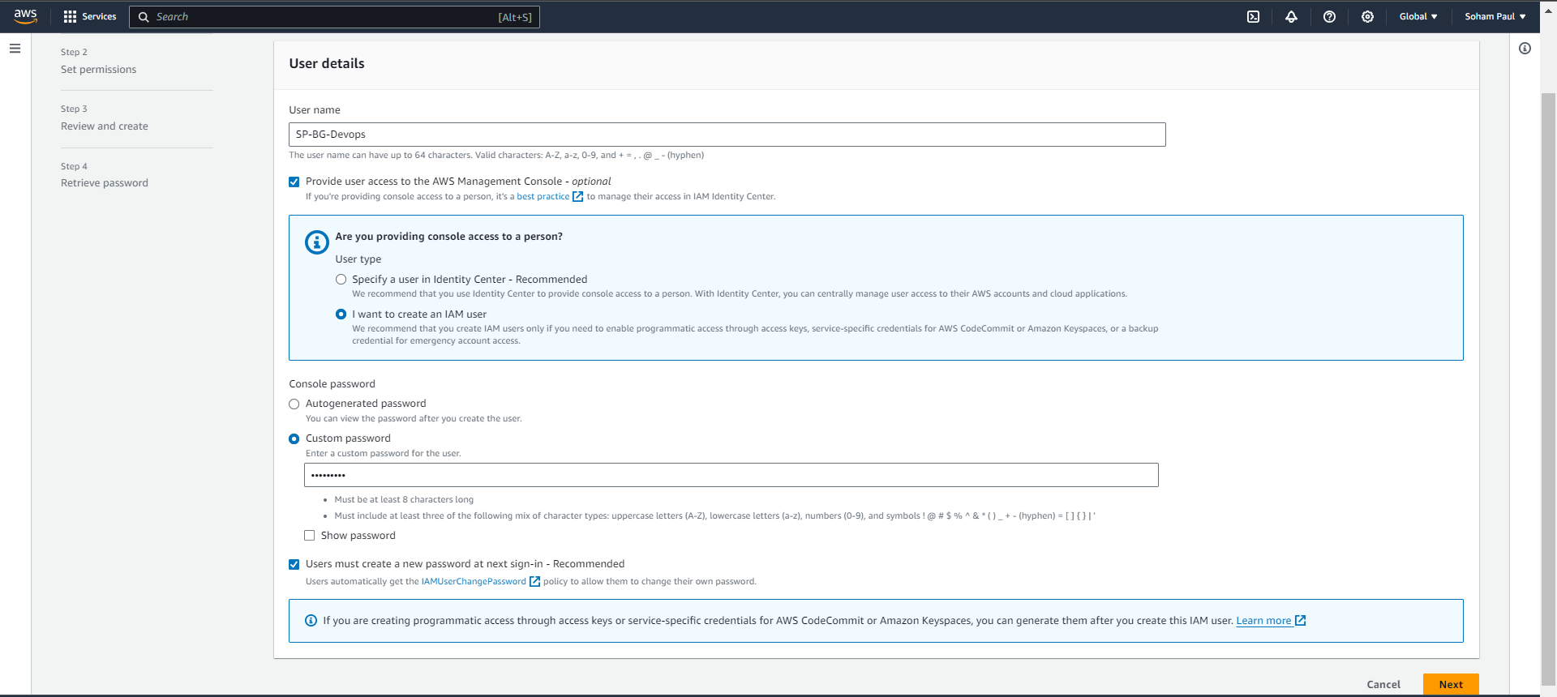

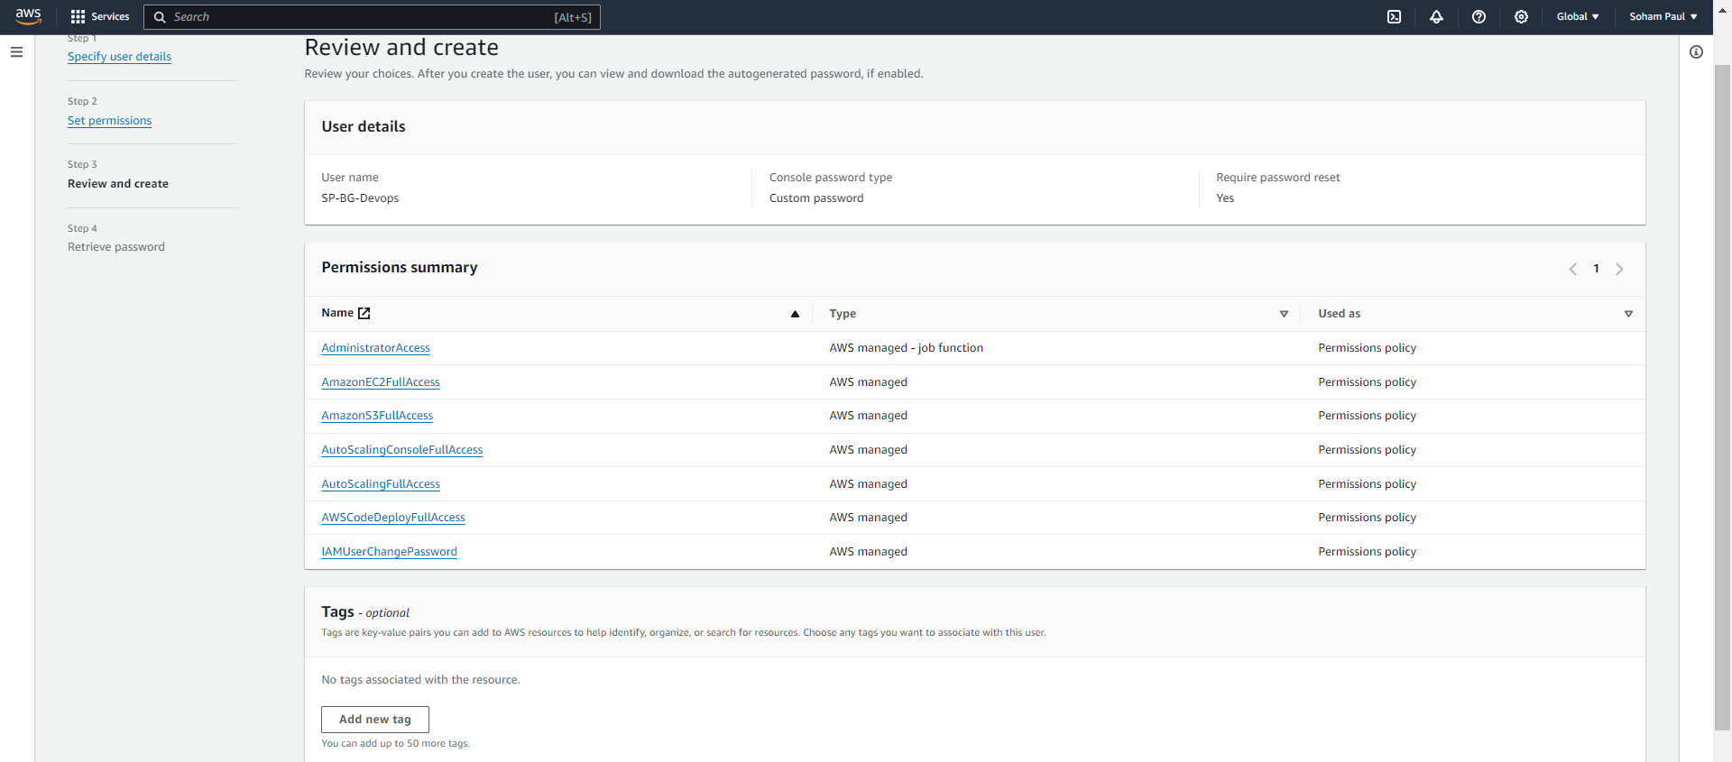

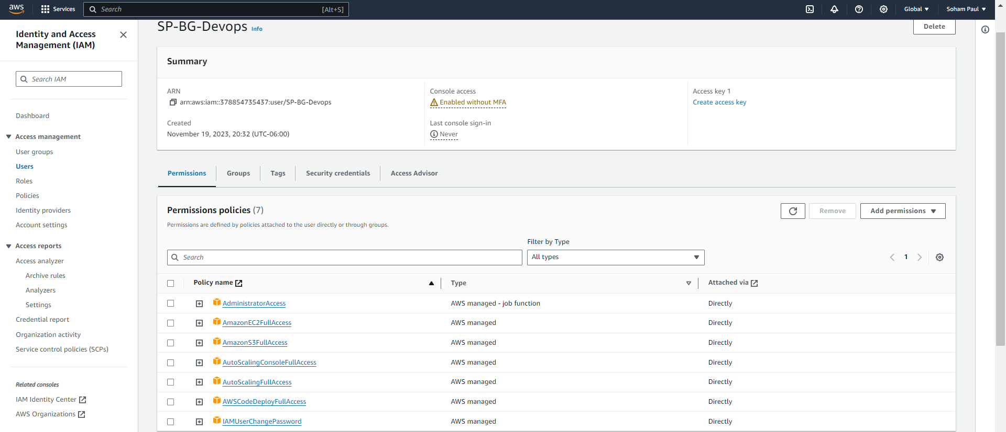

TASK 2: Create an S3 bucket <your-name-blue-green> and enable Versioning as well. (AWS Bucket region - Change Region to US East (Ohio) us-east-2)

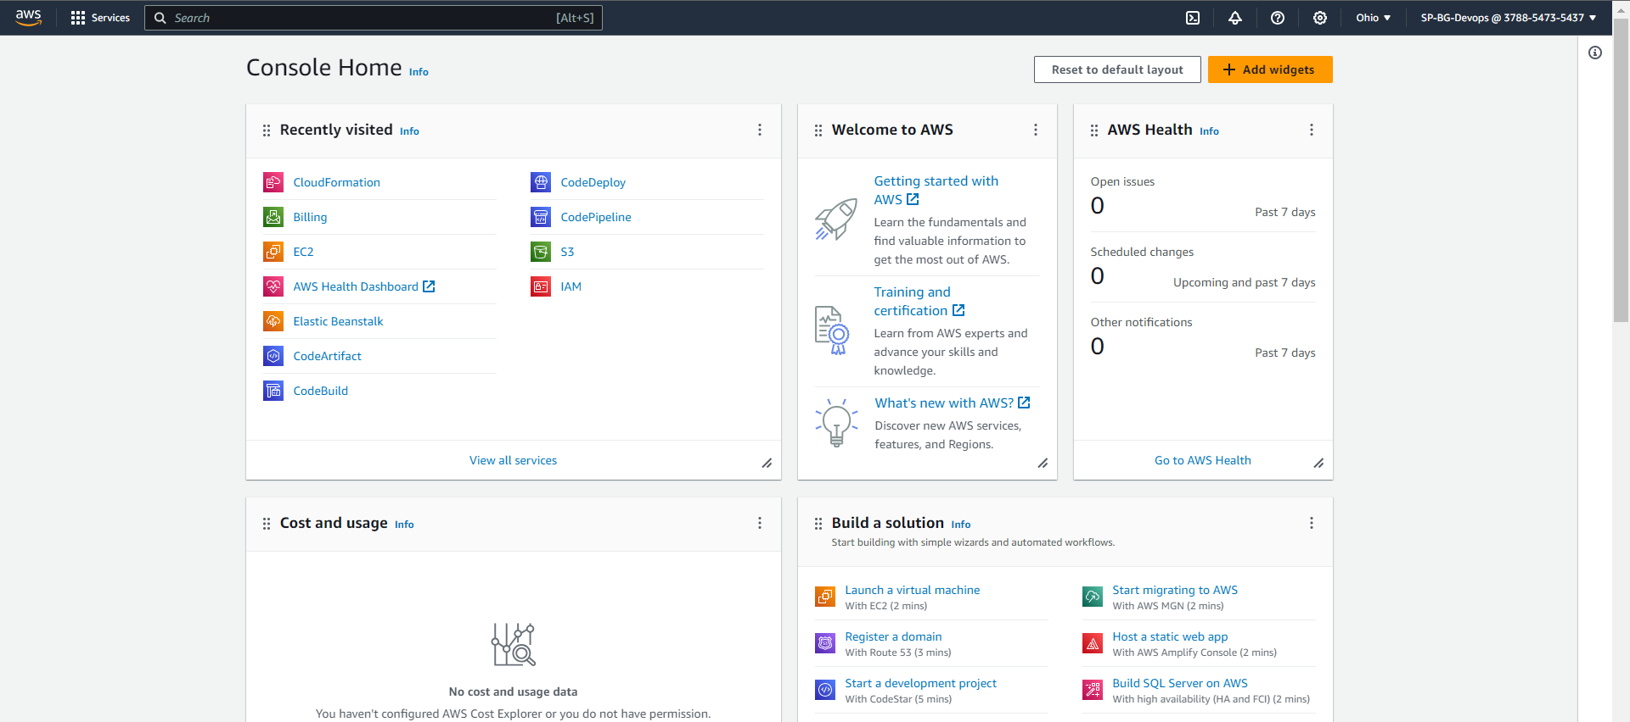

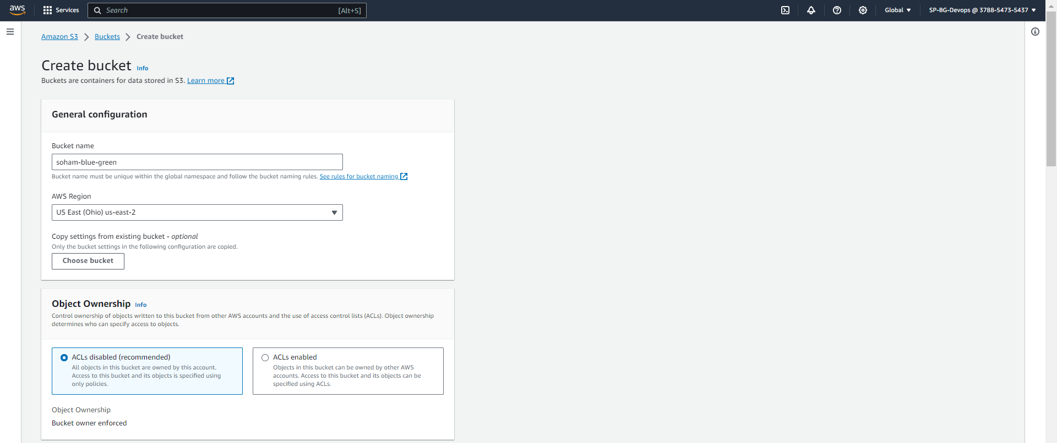

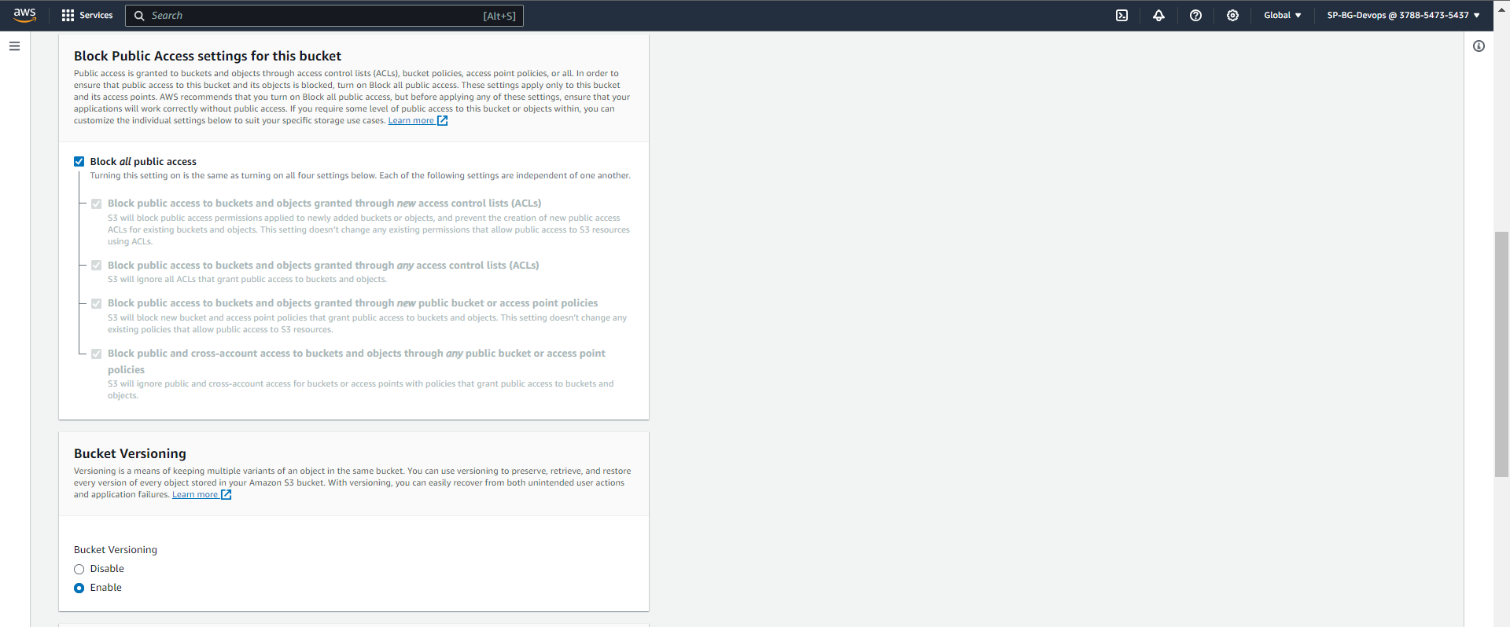

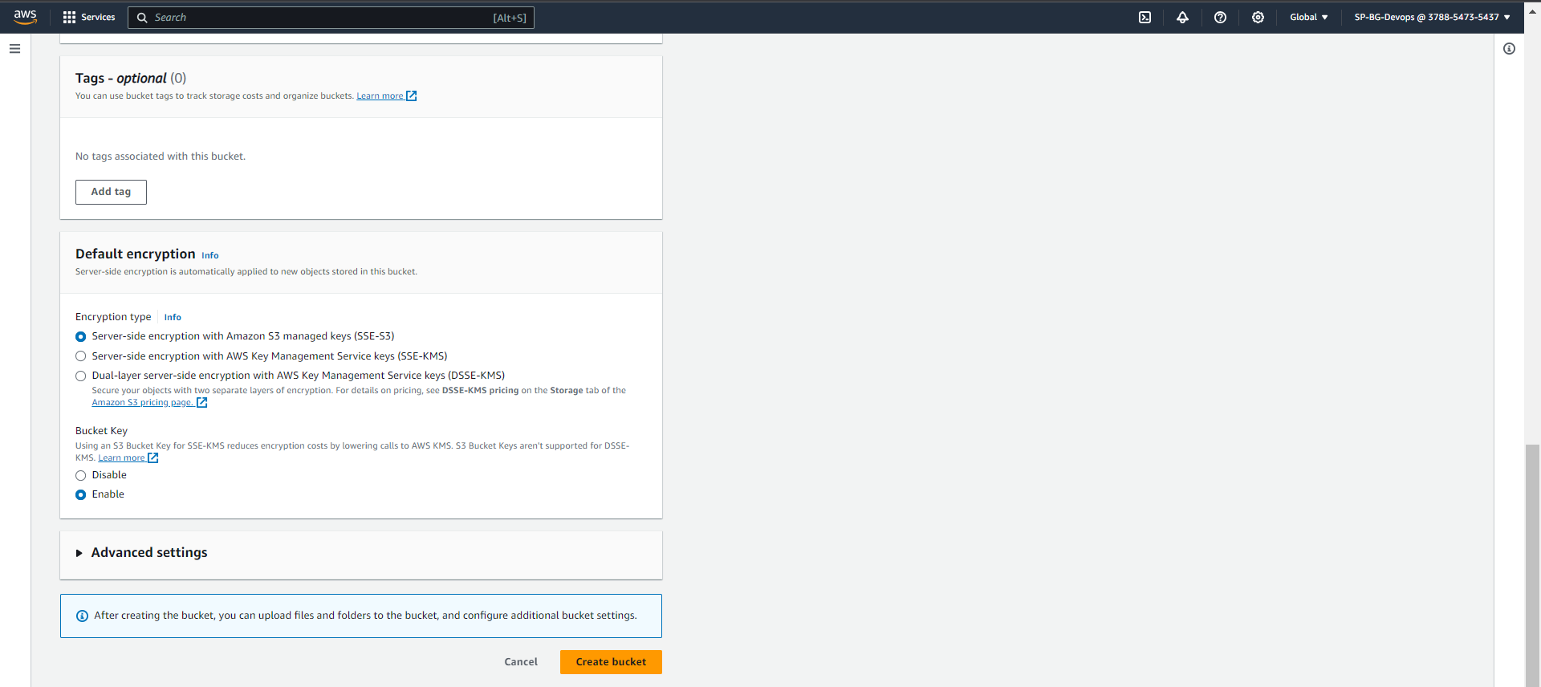

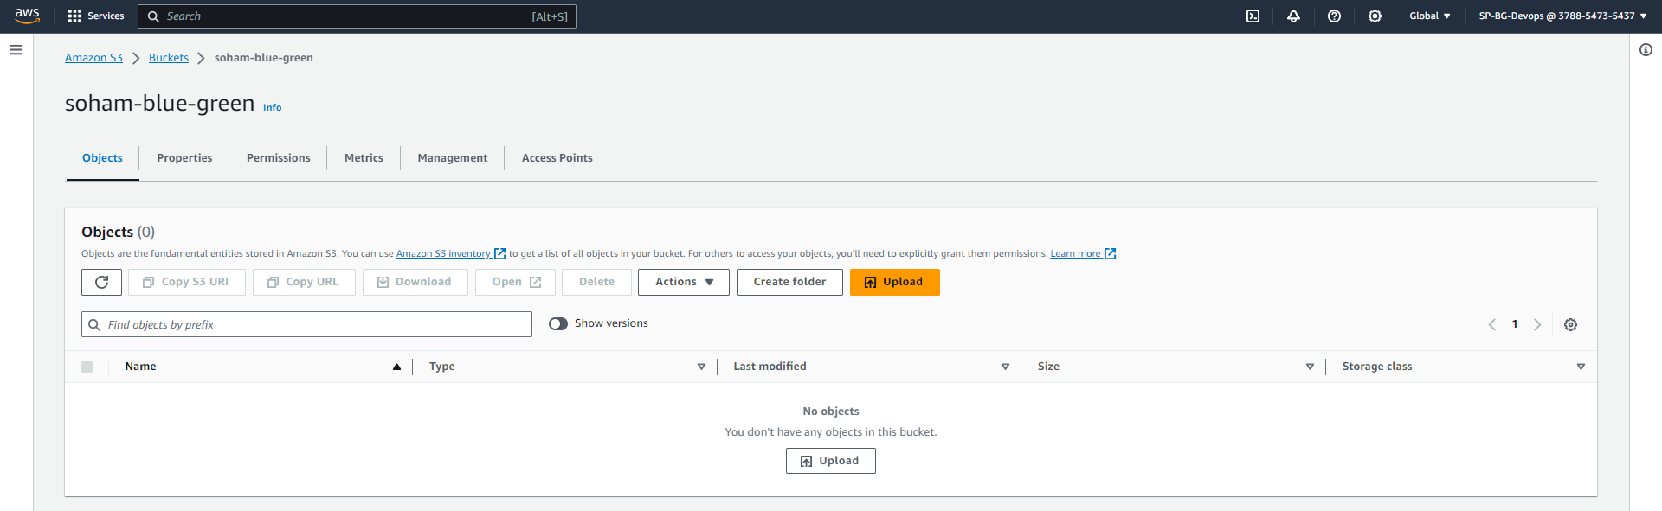

TASK 3: Navigate to IAM and create a new policy in JSON name as CodeDeployPerm and paste the following (Replace your s3 bucket name in resource)

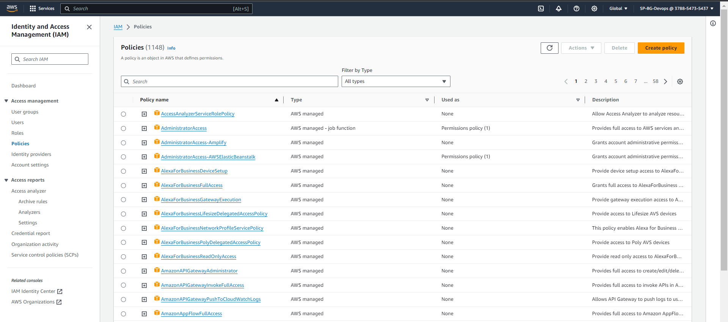

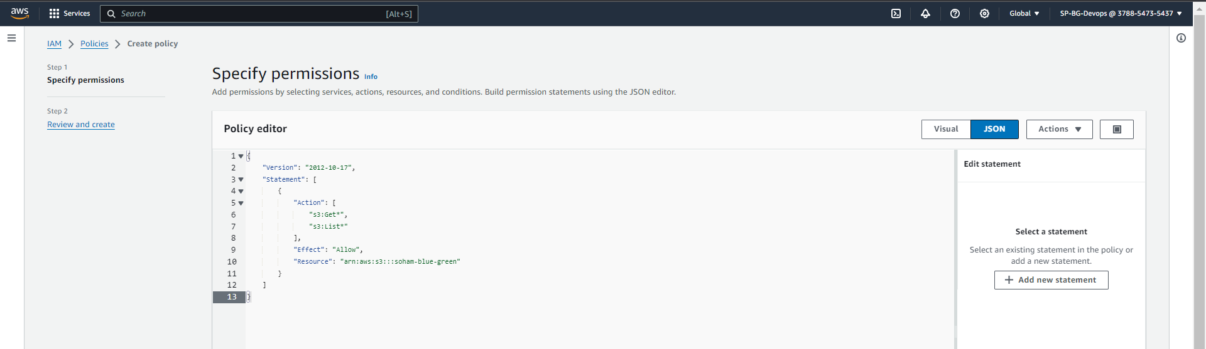

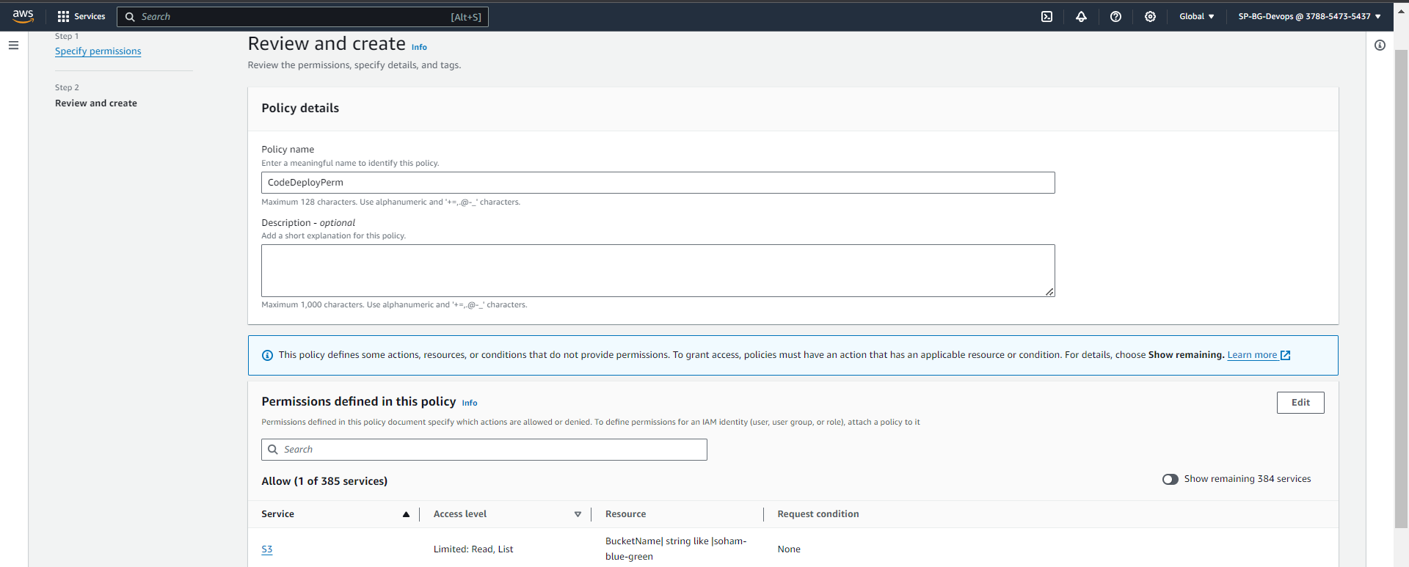

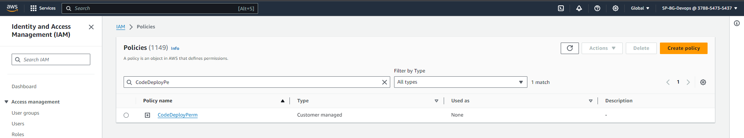

Create a new role (select EC2 service) with following policies attached and name it as <CodeDeployEC2-your-name>

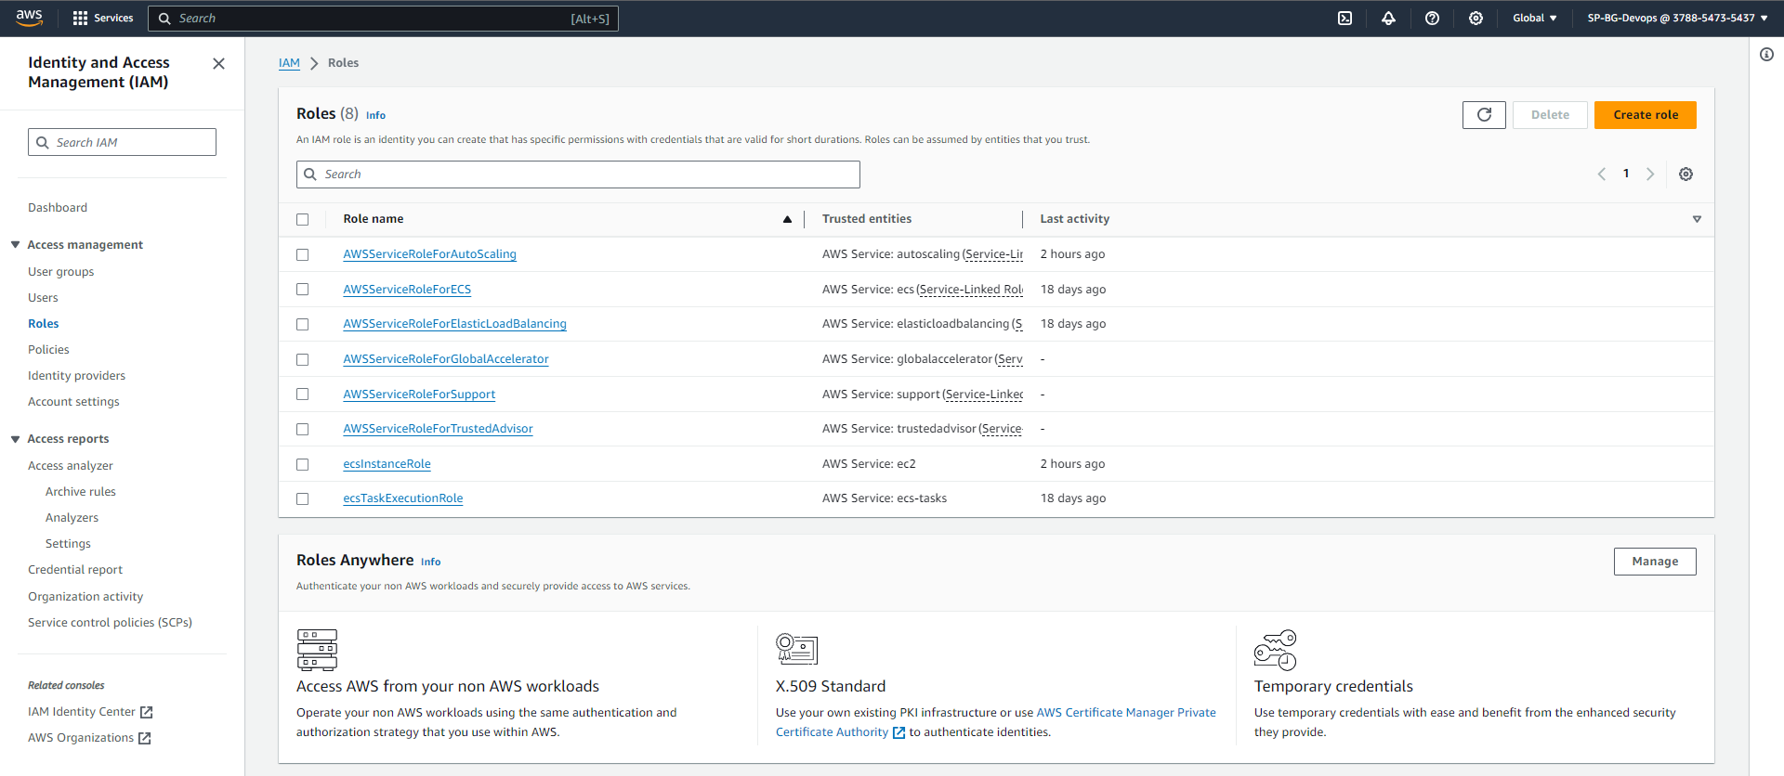

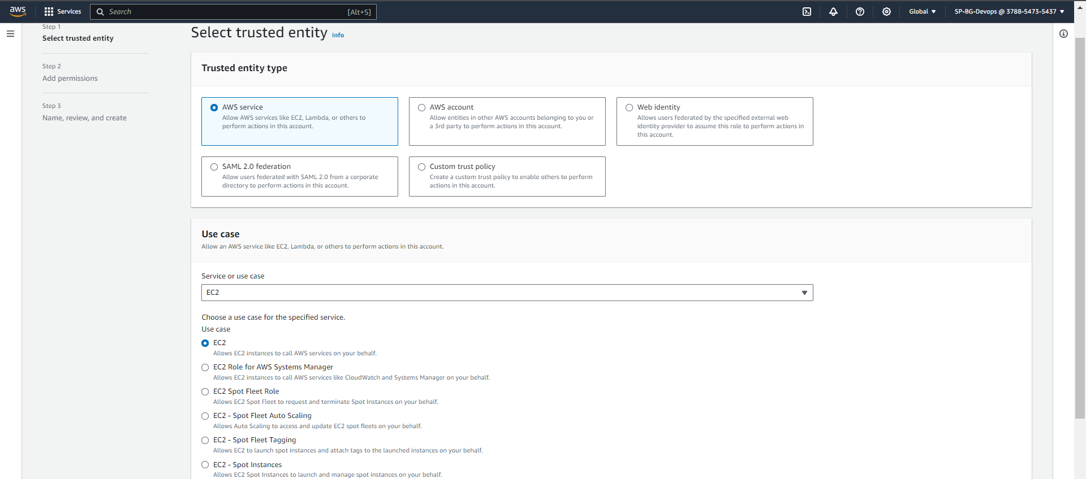

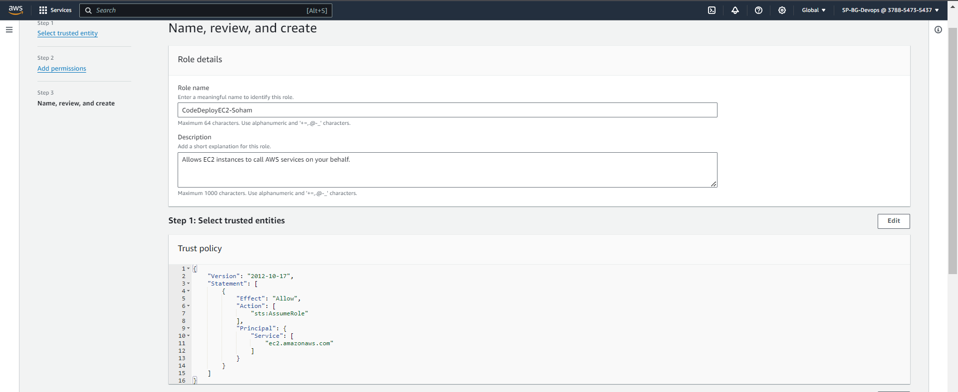

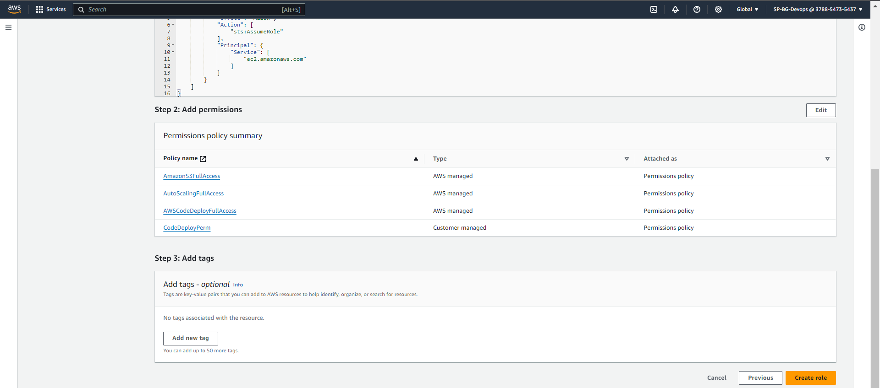

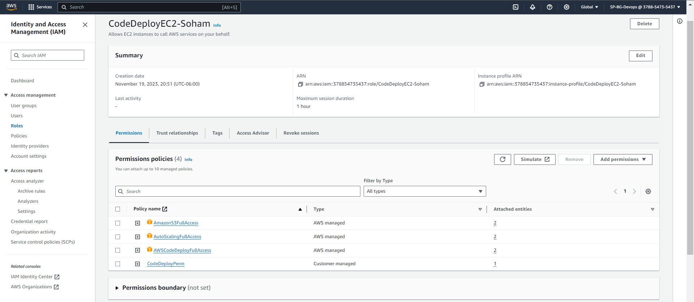

Create another role for CodeDeploy and name it as <CodeDeployService-yourname> Attach Policies shown below.

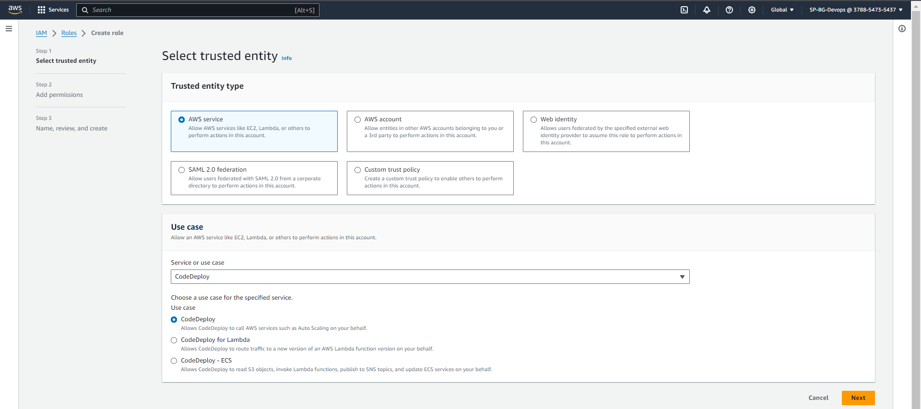

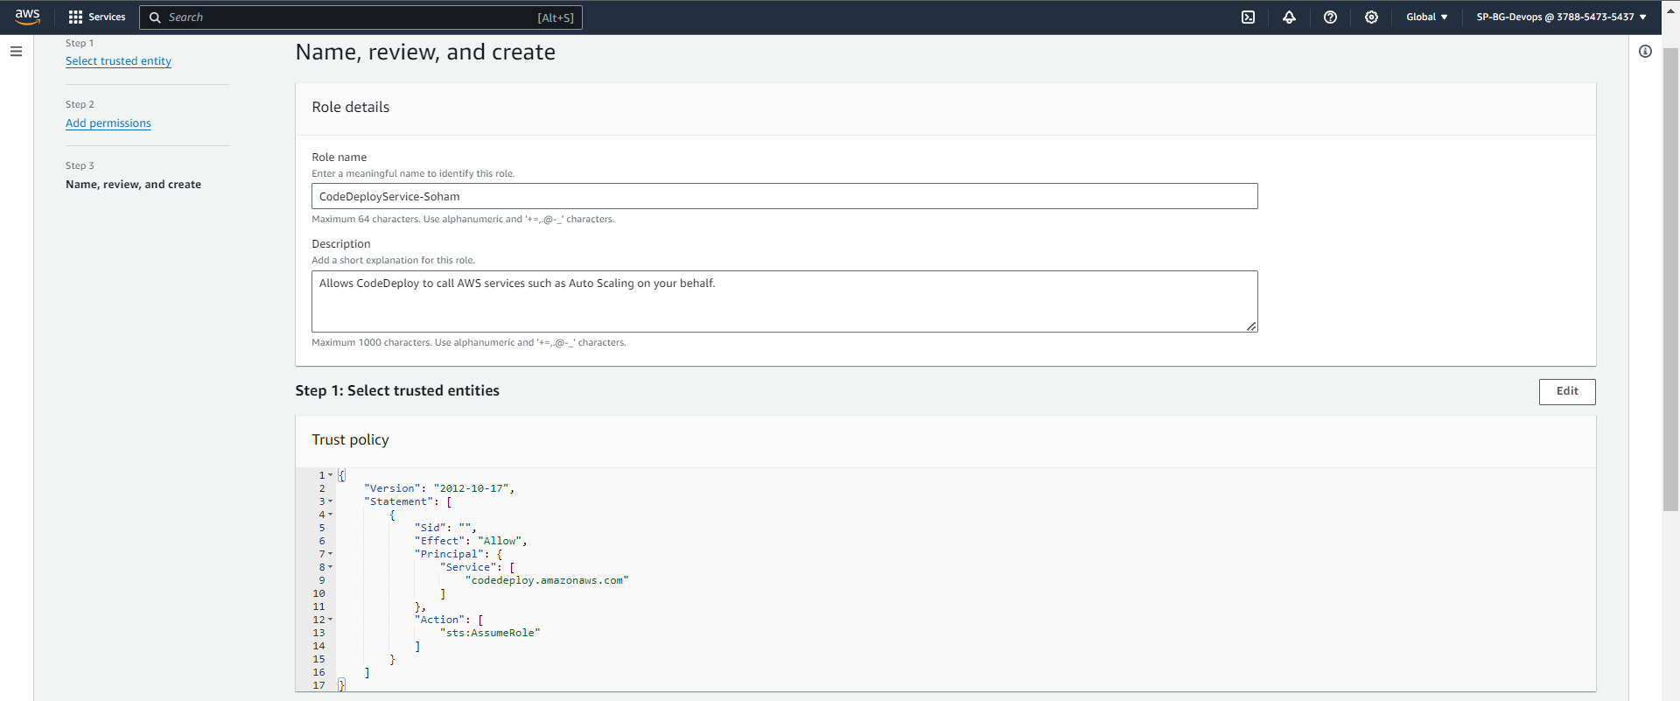

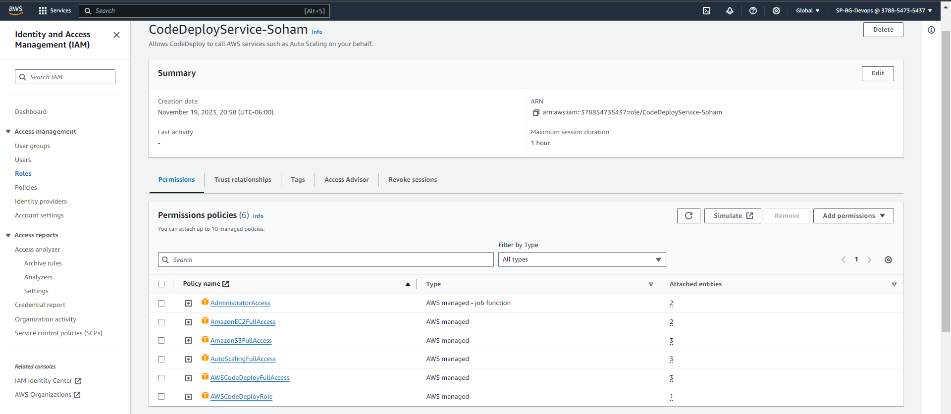

Theory question:

**Q) Explain what IAM policies, roles and users are?**

**Ans:** IAM plays a pivotal role in managing user access within cloud computing services, offering organizations effective control over resource permissions. IAM policies, comprising rules governing permitted or restricted actions on resources, are linked to users or roles to regulate access across various AWS resources. IAM roles function as entities with precise permissions, often assumed by users or services, providing a means for meticulous control to ensure users or services only have essential permissions for their designated tasks. IAM users are individual entities with unique credentials, typically representing organizational members, and can be assigned to IAM groups, assuming specific roles aligned with their responsibilities in the system.

TASK 4: Creating EC2 instance

Create a new key-pair:

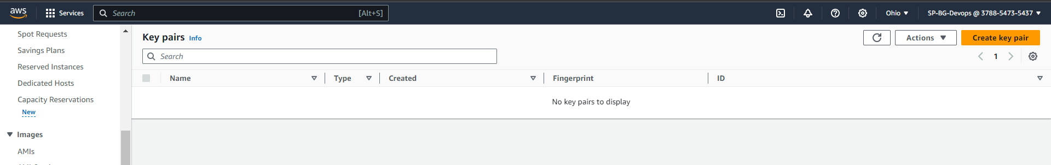

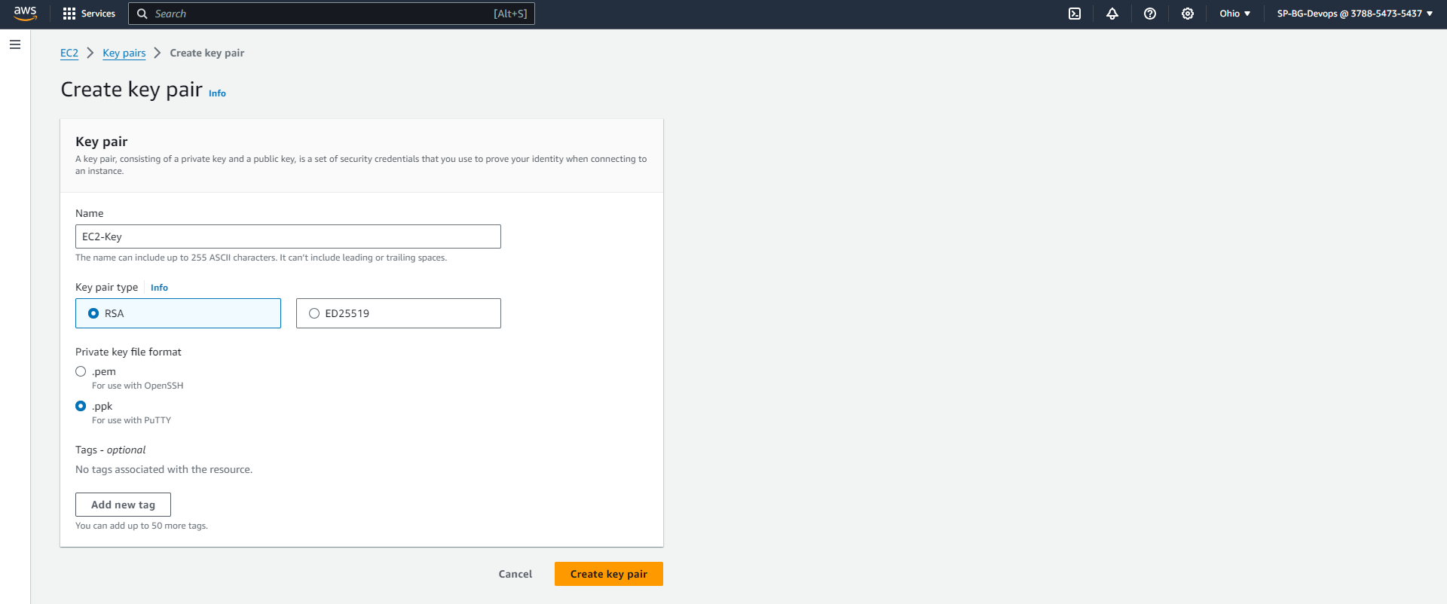

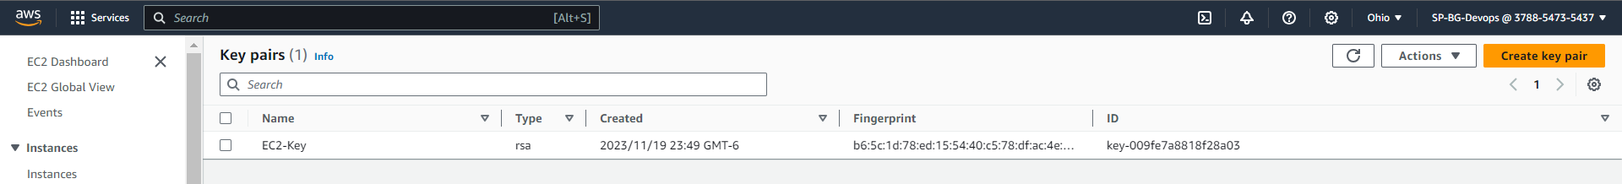

Name the instance as <your-name-BGlab>. Select the newly created IAM role for EC2.

Create a new security group named as <your-name-SG>.

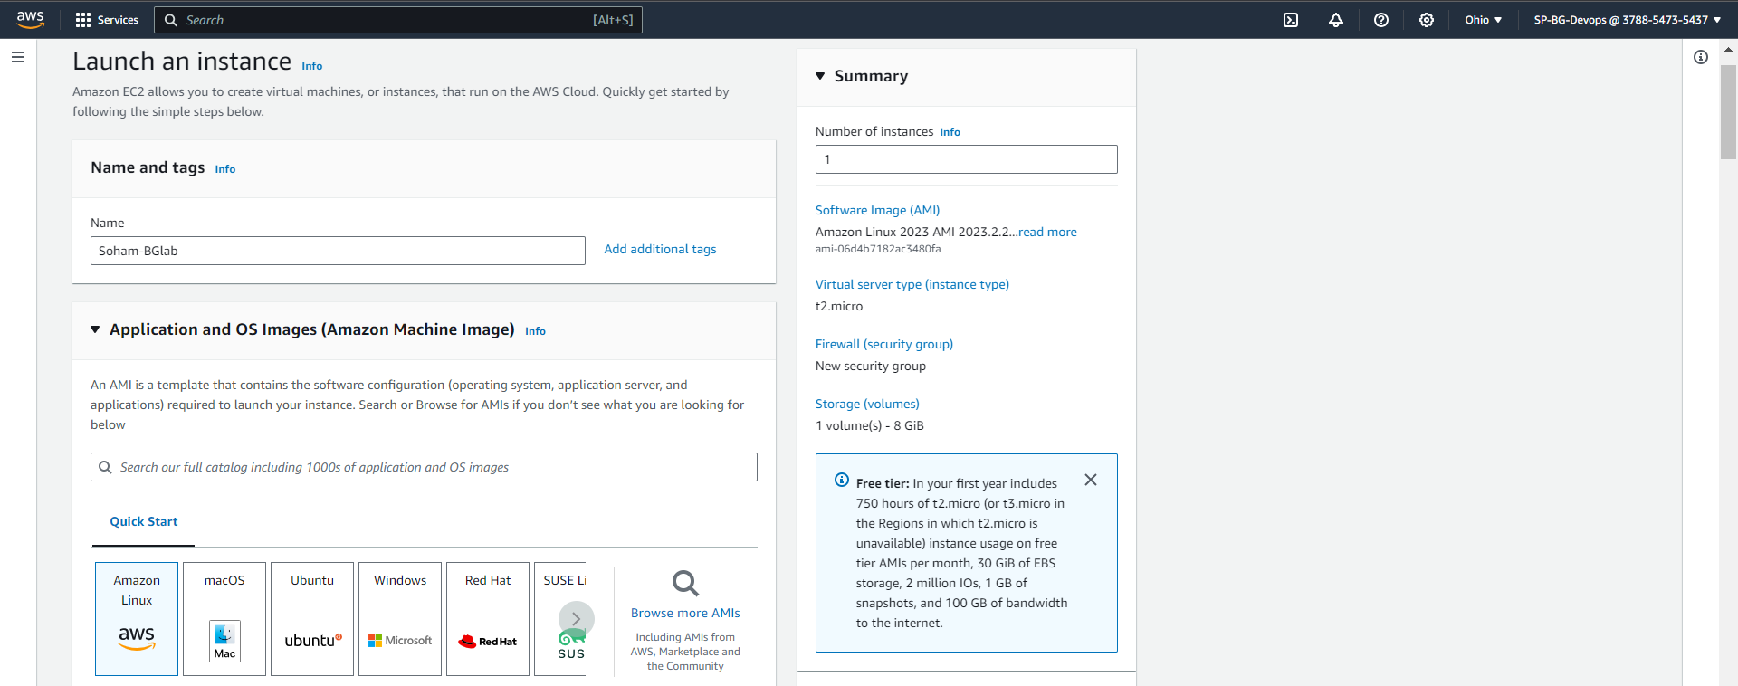

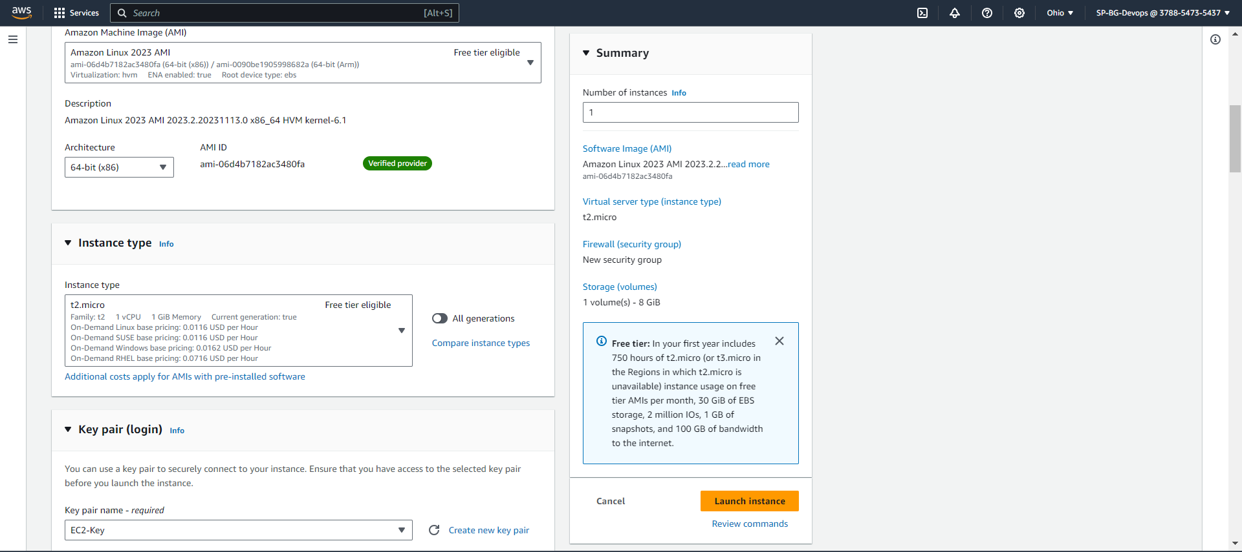

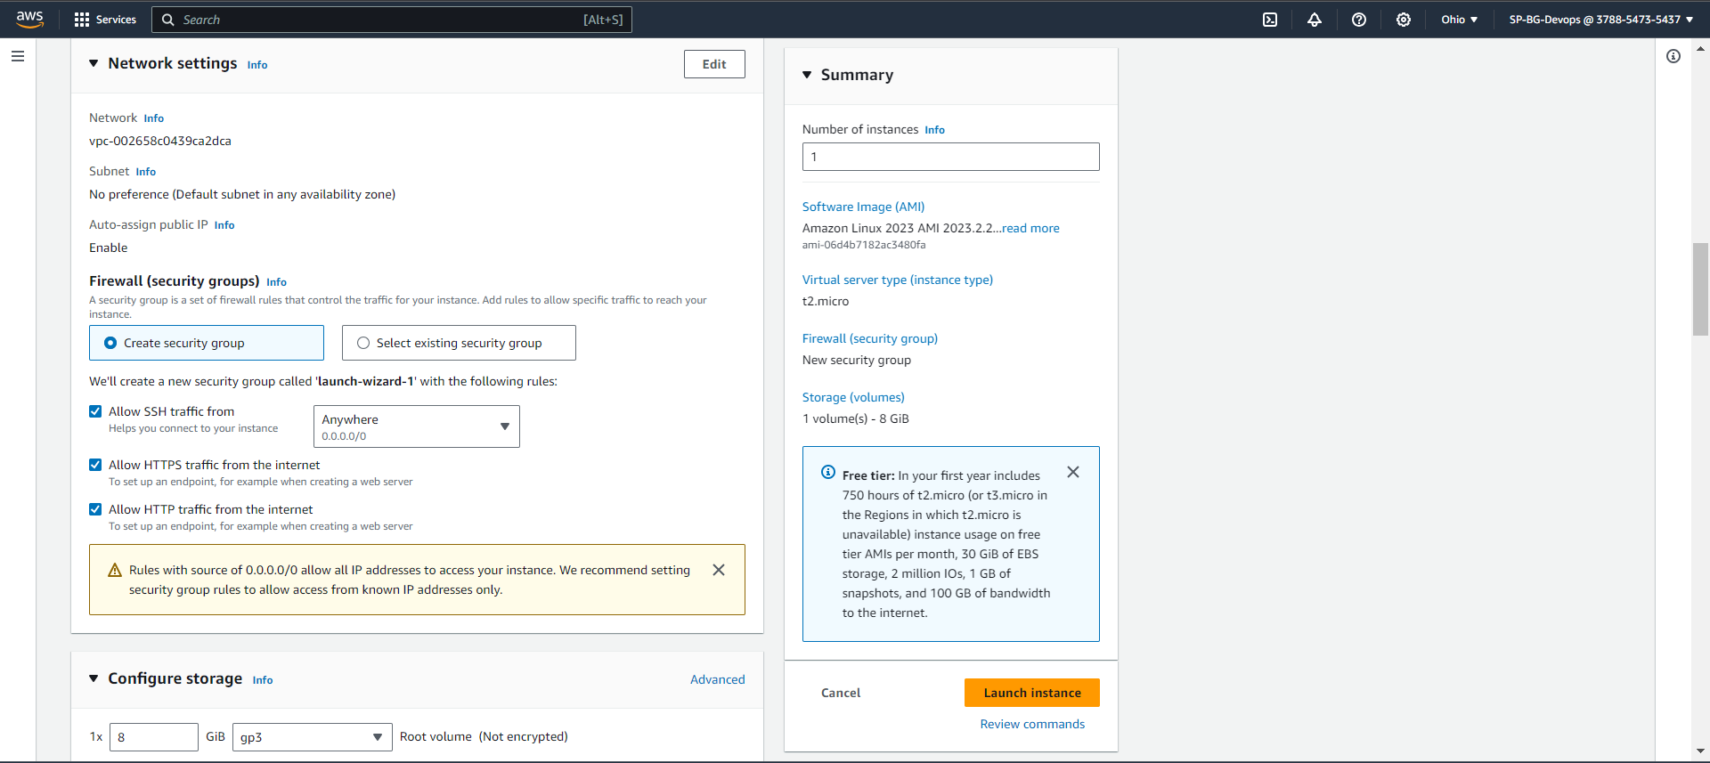

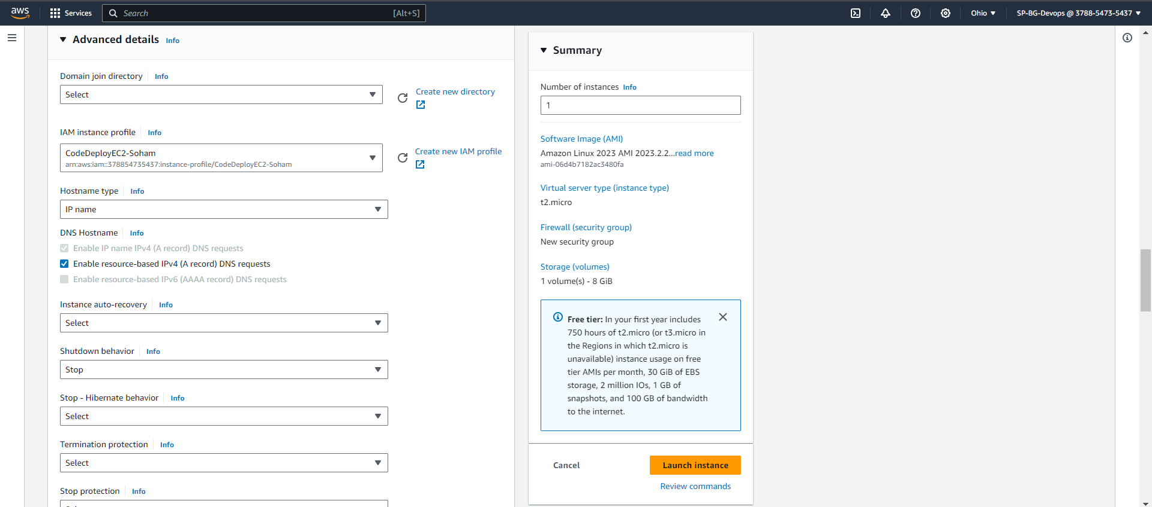

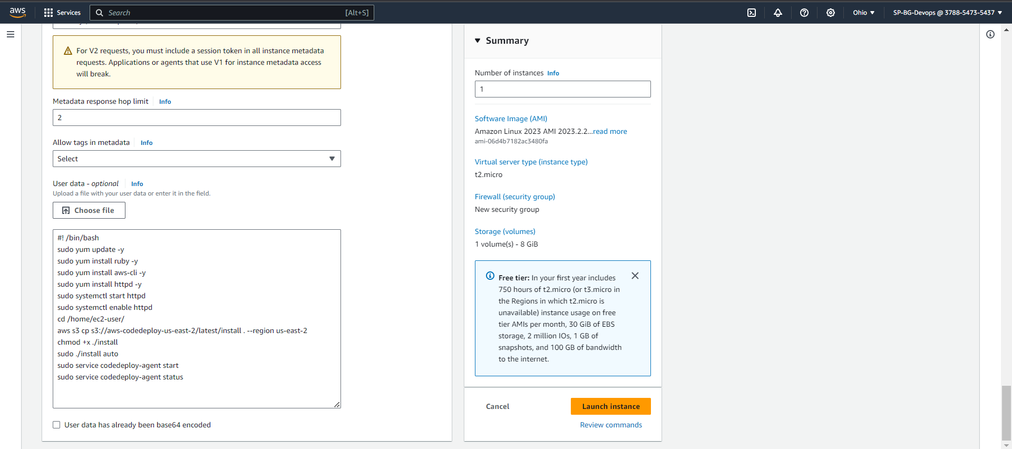

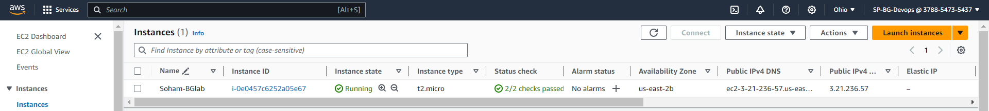

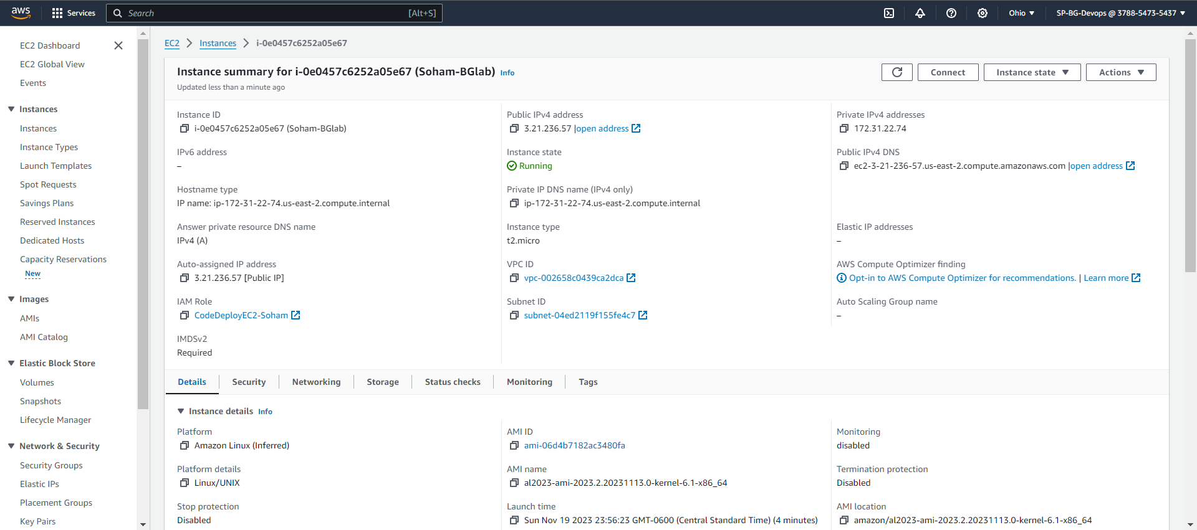

Log into instance using any terminal and check if CodeDeploy agent & httpd is running or not.

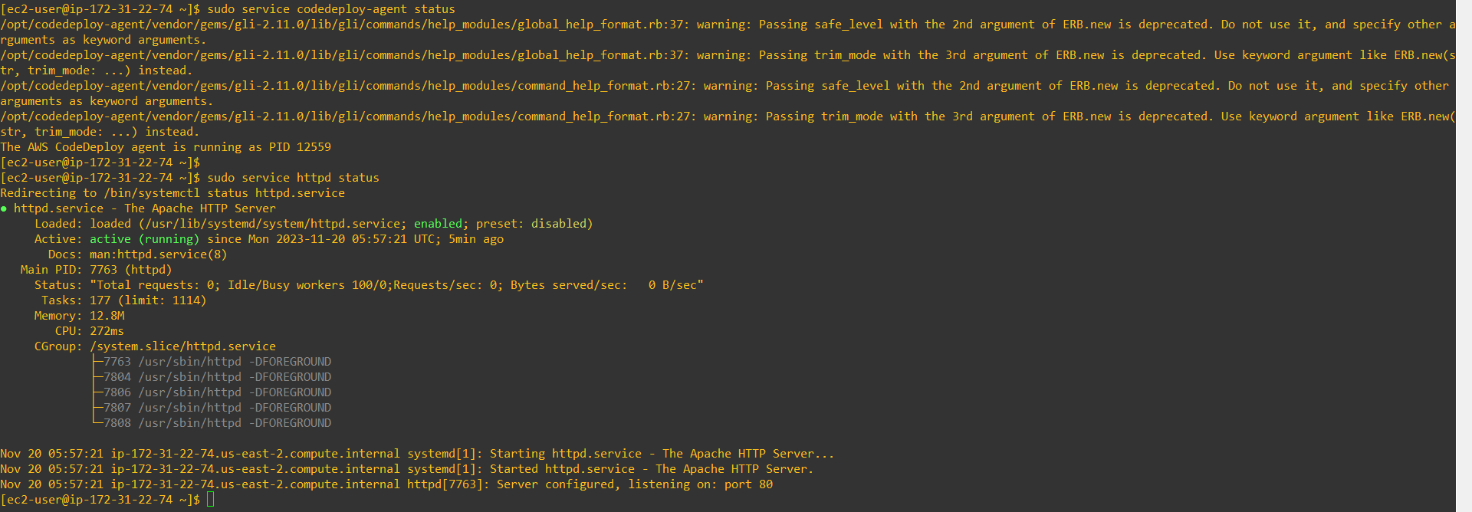

TASK 5: Creating an Application Load Balancer

Step 1: Navigate to EC2 and select Load Balancers under Load Balancing and create a new Load Balancer: Select Application Load Balancer. Select all Availability zones & Select the Security group you created earlier. Create Target Group use following Details shown in Images below. Wait for the state to change from provisioning to active.

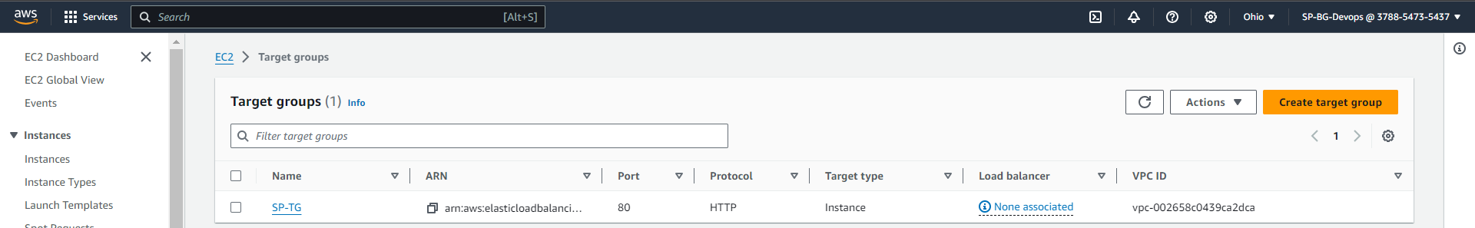

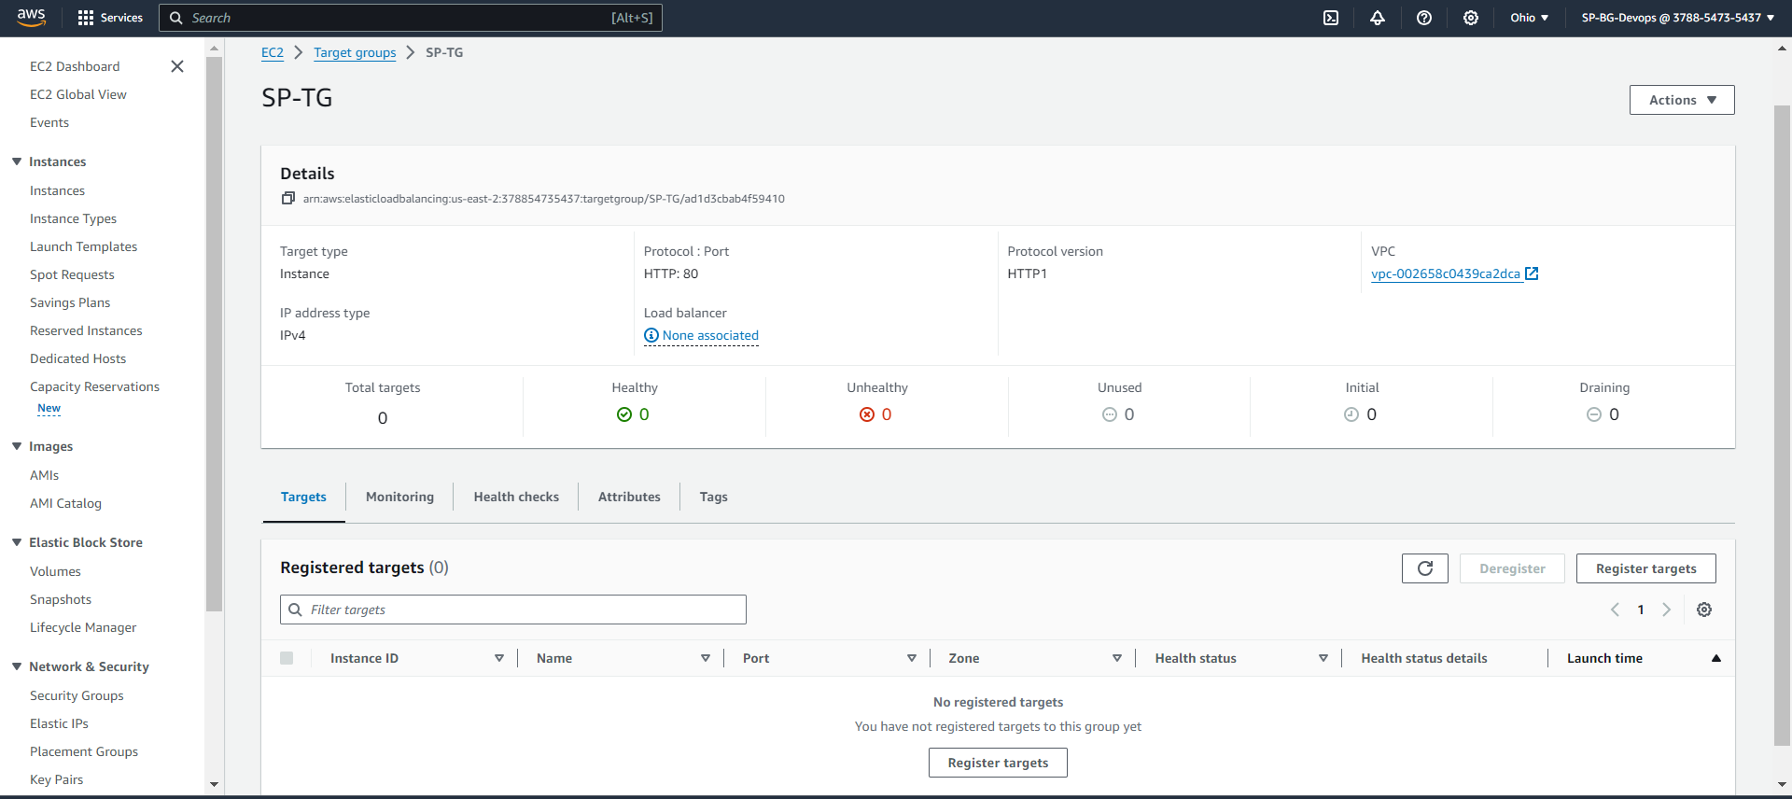

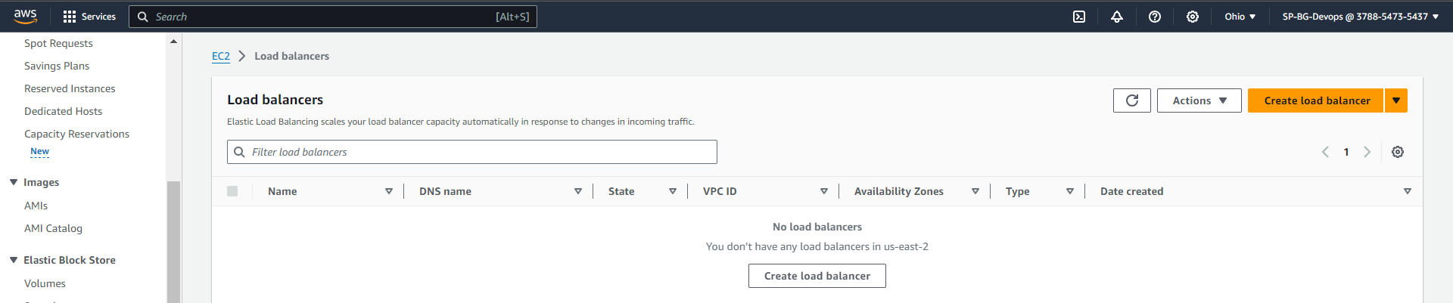

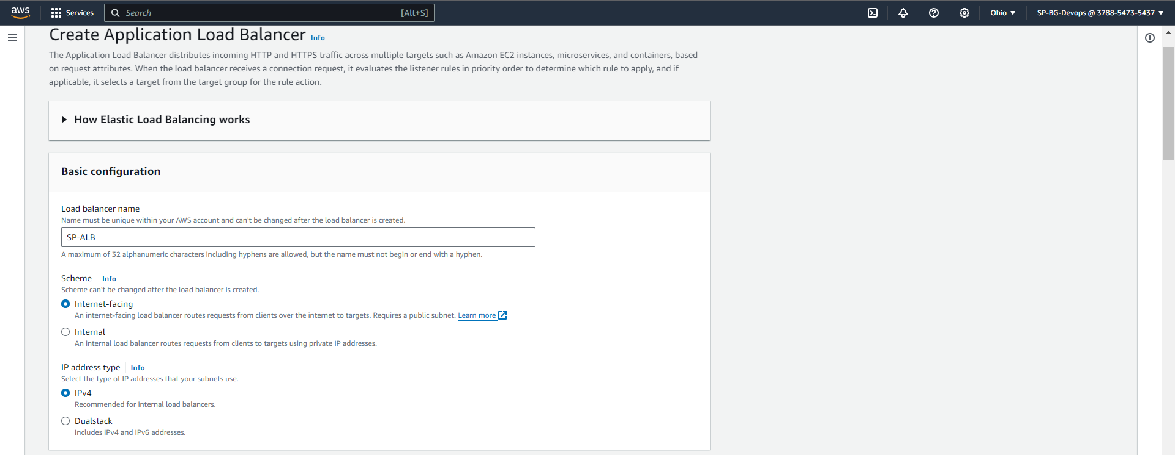

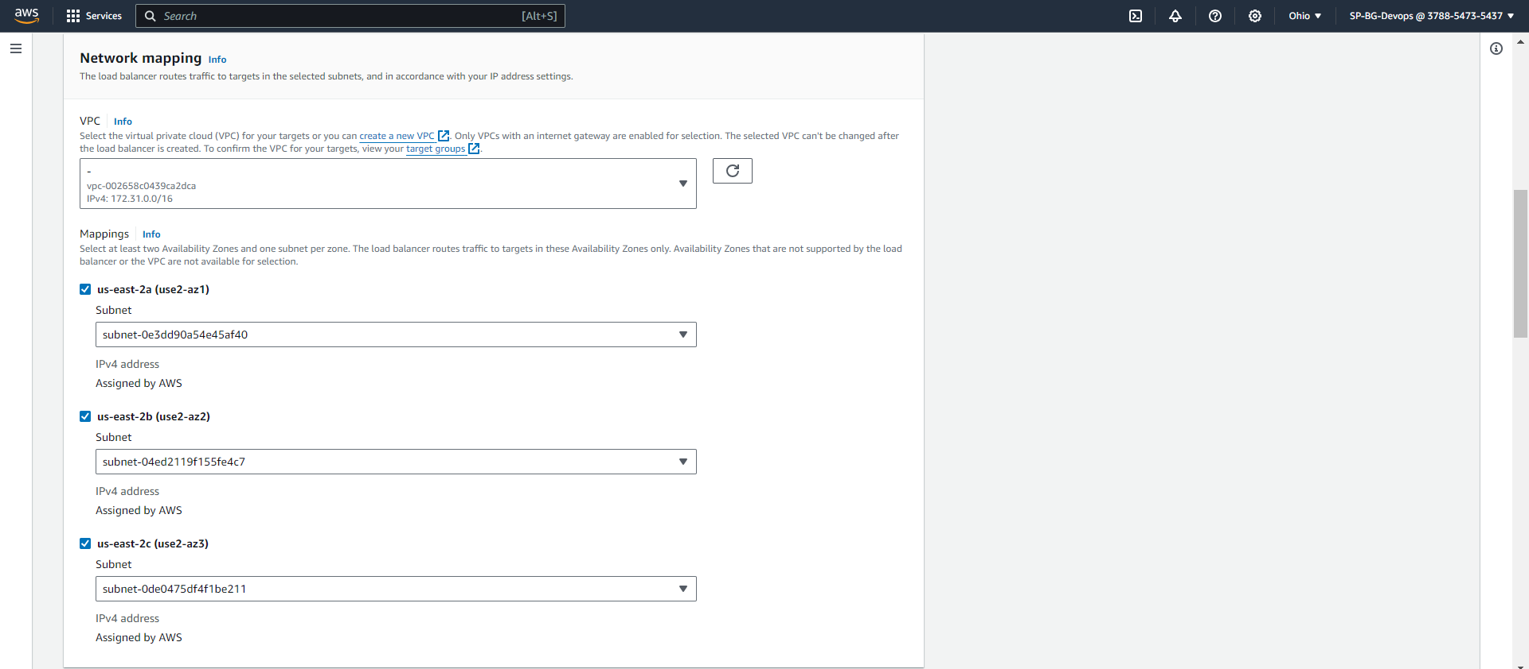

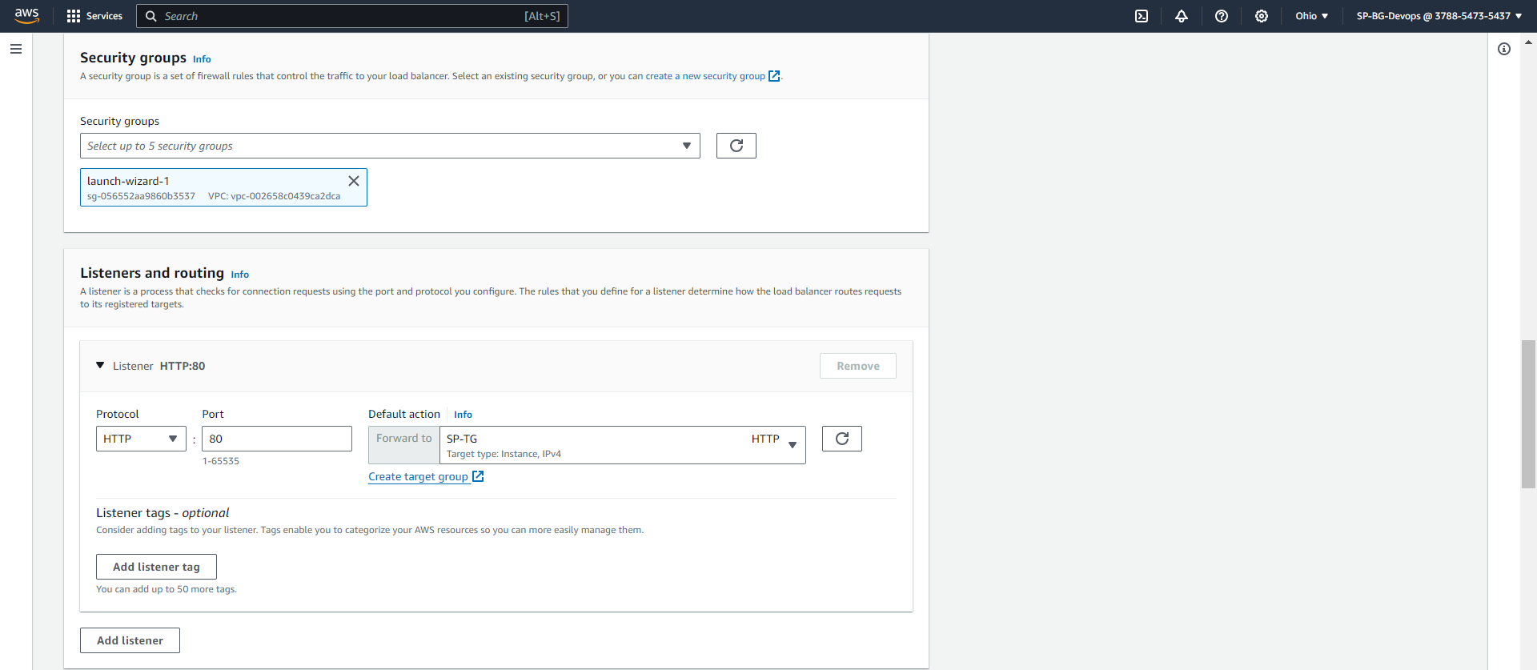

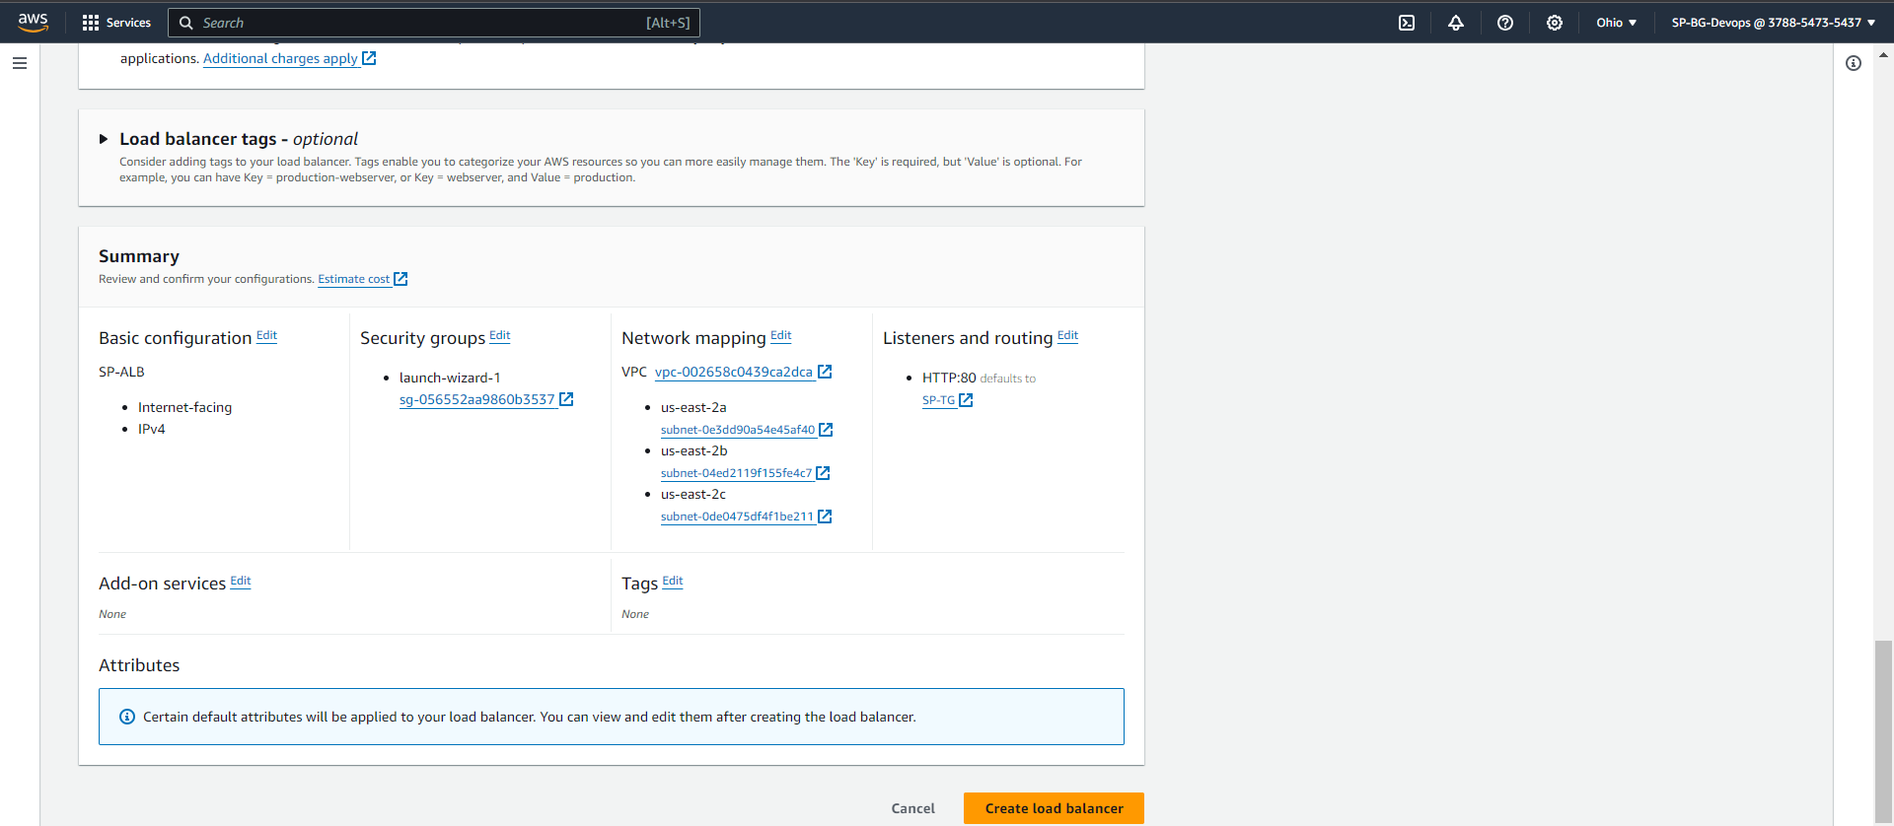

Wait for the state to change from provisioning to active:

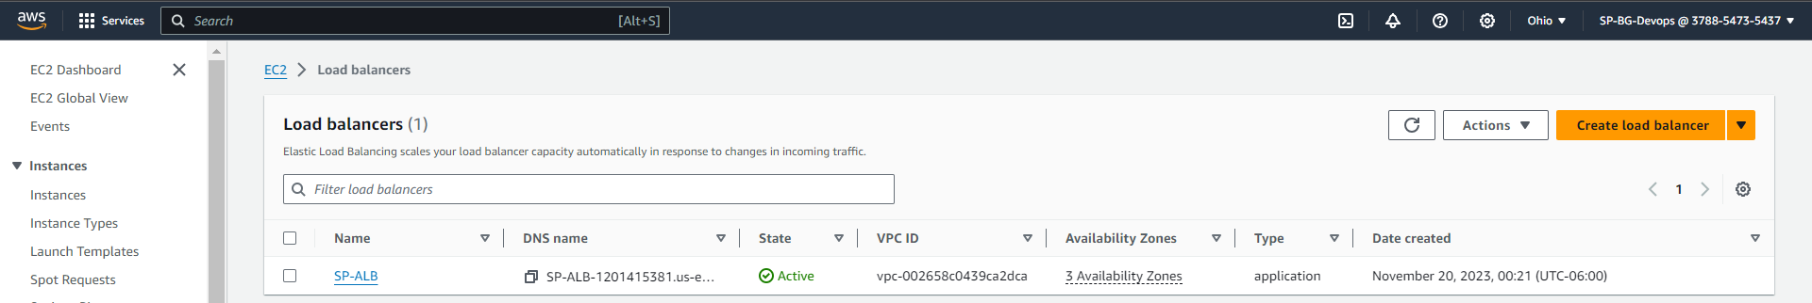

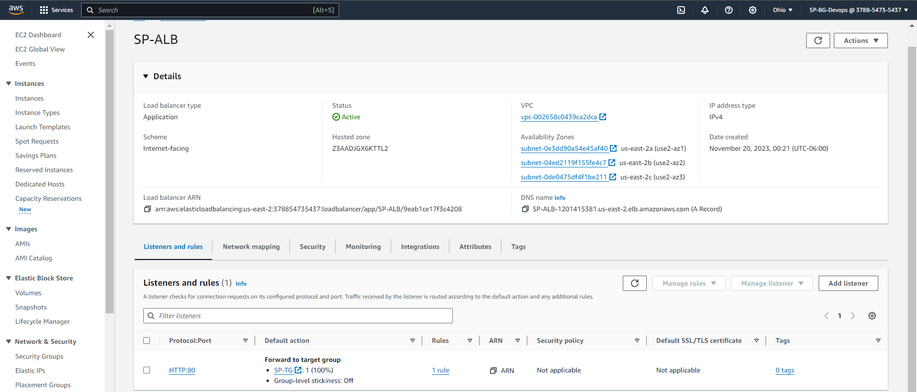

STEP 2: Navigate to EC2 Dashboard and create a template from your instance and name it as <yournameTemp>:

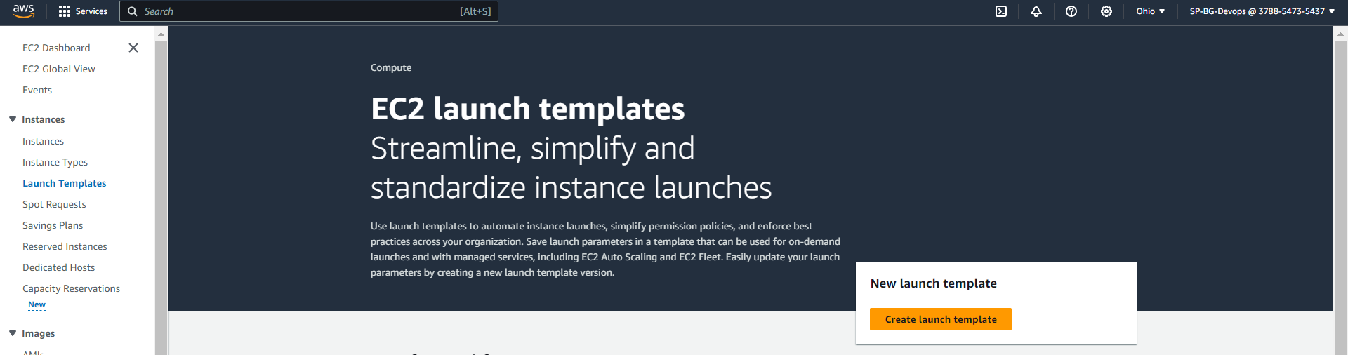

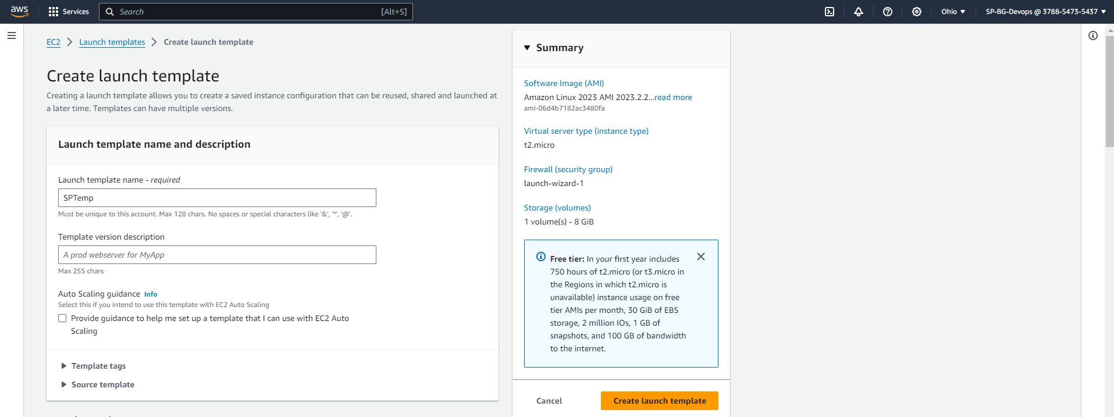

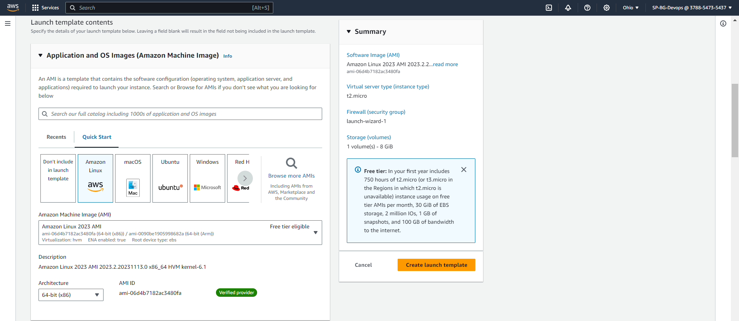

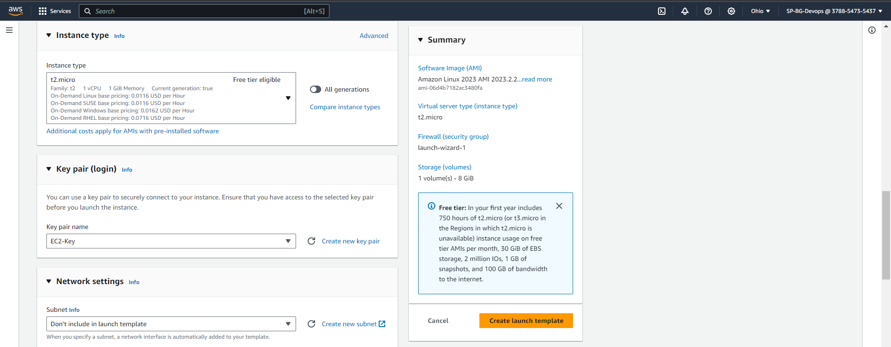

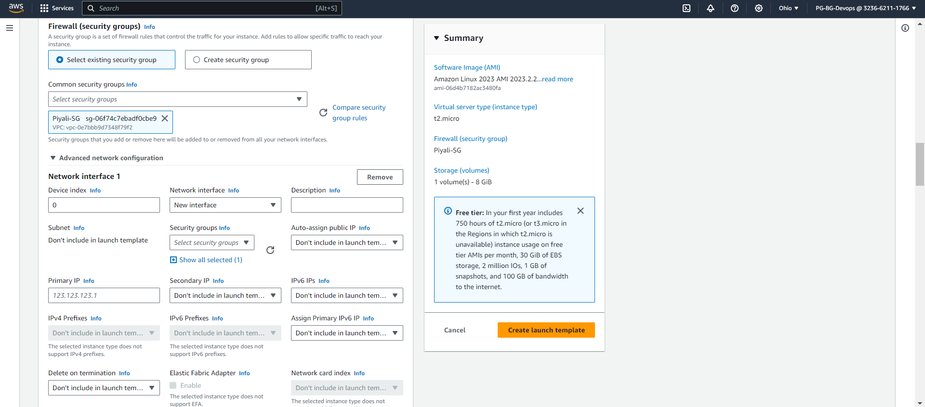

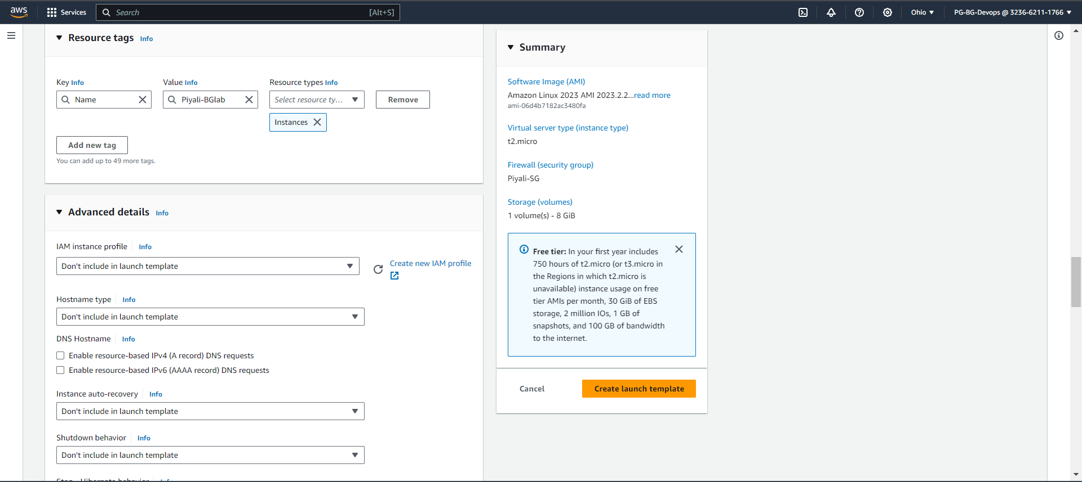

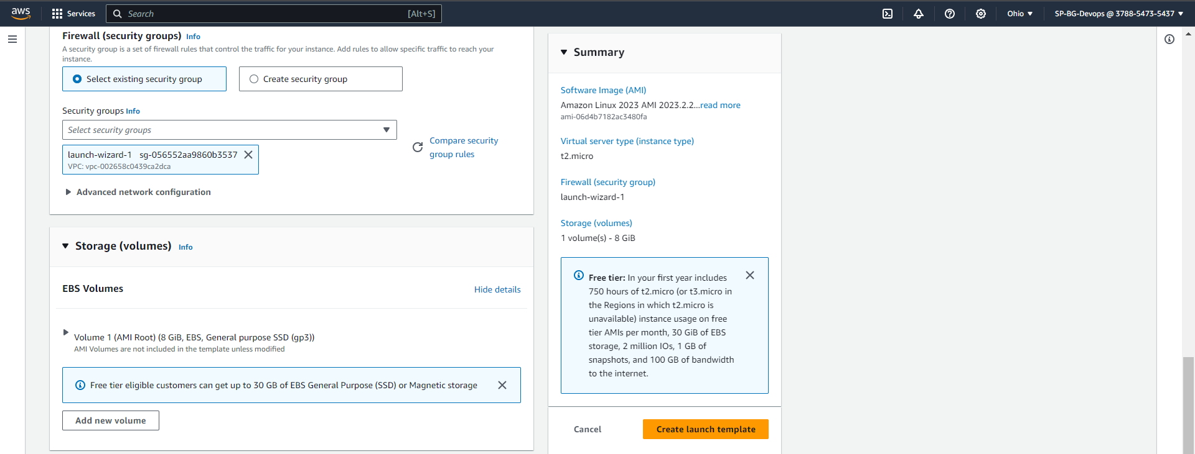

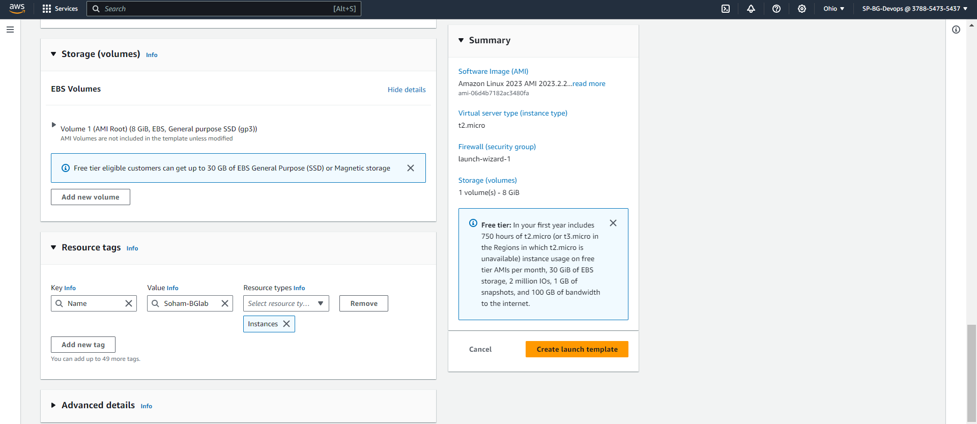

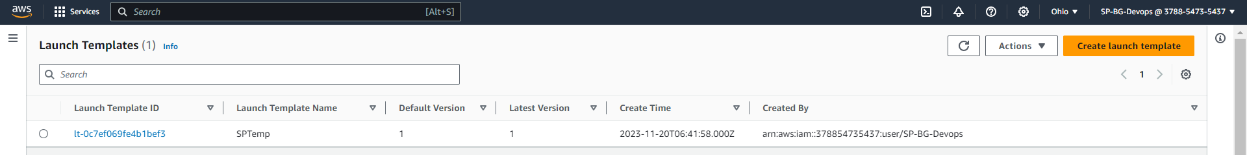

STEP 3: Creating an Auto-Scaling Group:

Name the Auto Scaling group as <yournameAS> and choose the template created Select all the subnets. Enable Load Balancer and select out Target group. Select the Group size and create.

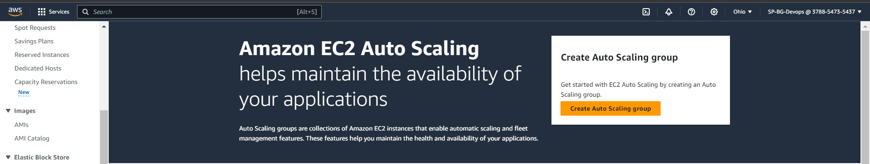

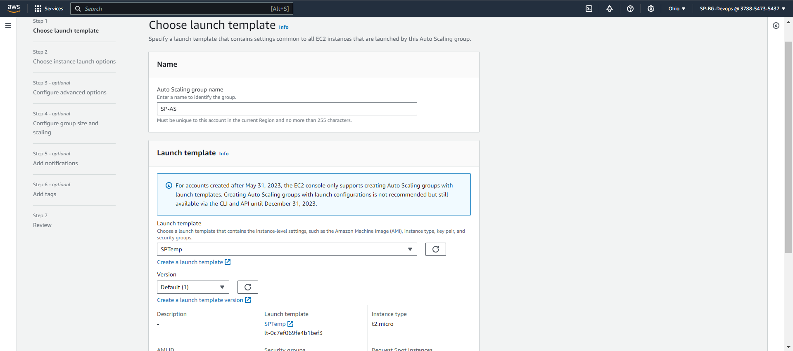

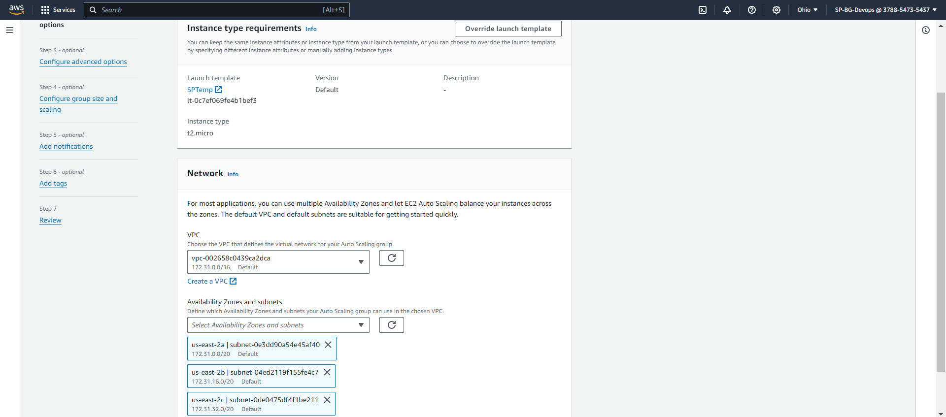

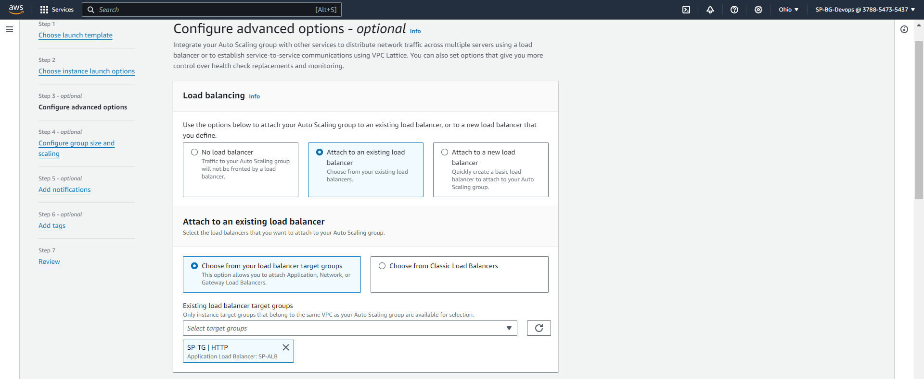

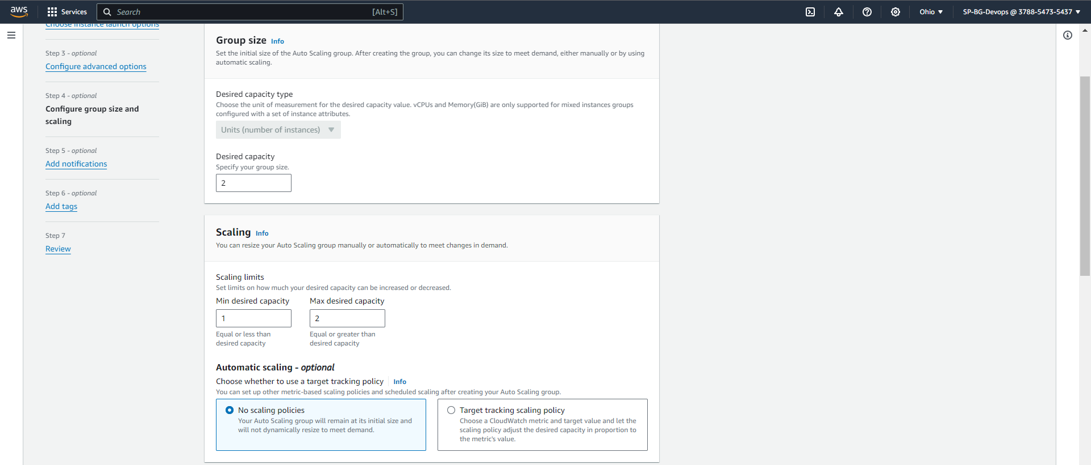

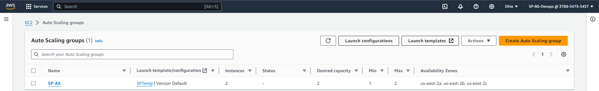

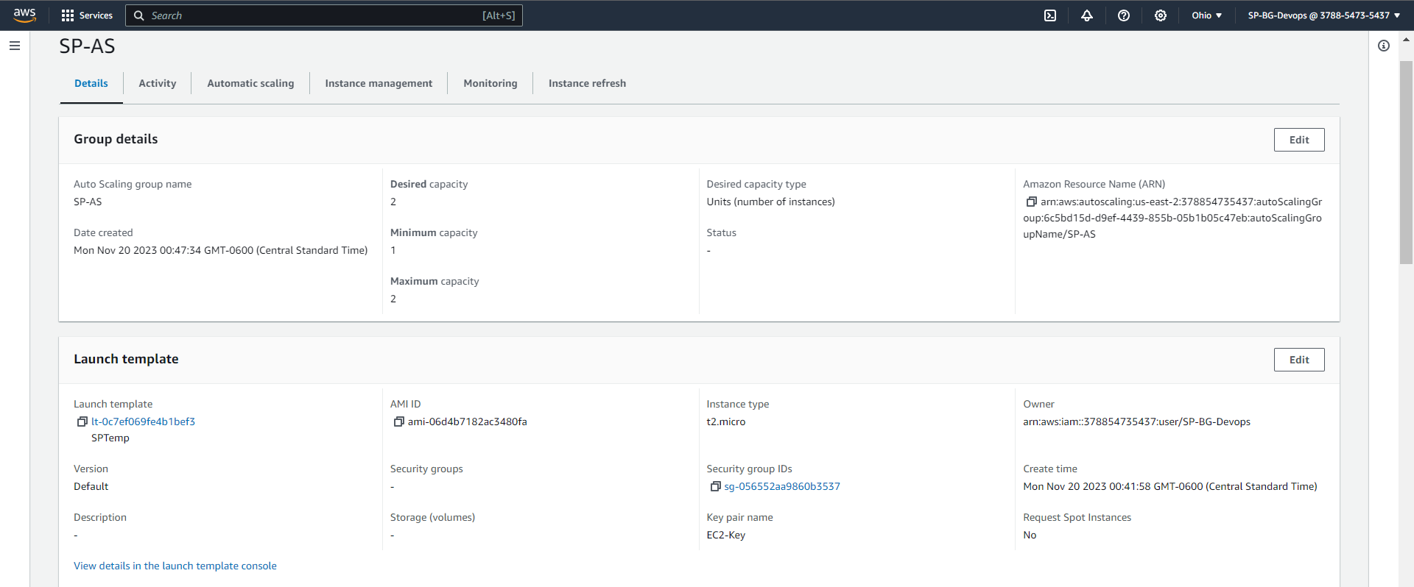

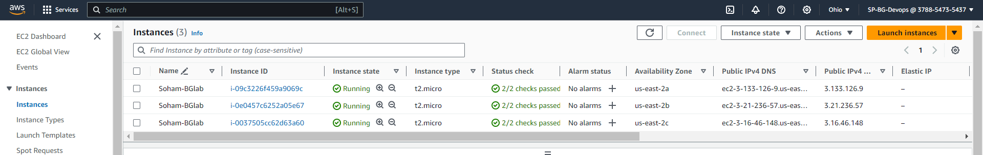

**Theory questions:**

**Q) Explain what an Auto-Scaling group is**

**Ans:** An Auto Scaling group is a key element in cloud computing which automatically adapts the quantity of computing resources, like virtual machines, in accordance with demand fluctuations or predefined criteria. By autonomously adding or removing instances based on user-set policies, it guarantees efficient resource utilization and optimal system performance. This feature is widely employed in scenarios with varying workloads, offering both flexibility and cost-effectiveness as it dynamically adjusts resource scaling to align with demand fluctuations.

**Q) What happens if I were to delete any instance after creating an Auto-Scaling group**

**Ans:** If an instance is deleted after creating an Auto Scaling group, the Auto Scaling service identifies the termination and initiates corrective measures by launching a new instance. This ensures the Auto Scaling group maintains the designated number of instances as specified. The fundamental objective of Auto Scaling is to automatically adapt the instance count, guaranteeing the specified capacity is upheld, regardless of instances being terminated due to reasons like manual deletion or hardware issues.

PART 2: Creating a CodeDeploy Application

TASK 1: Create a new application named as <yourname-BG> and choose EC2/On premises as compute platform

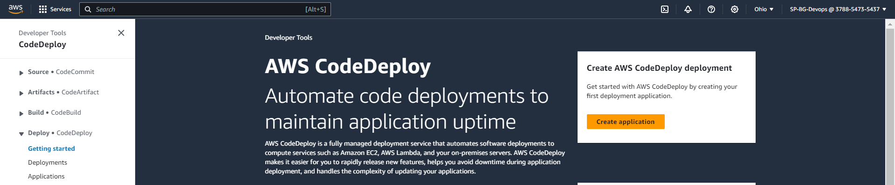

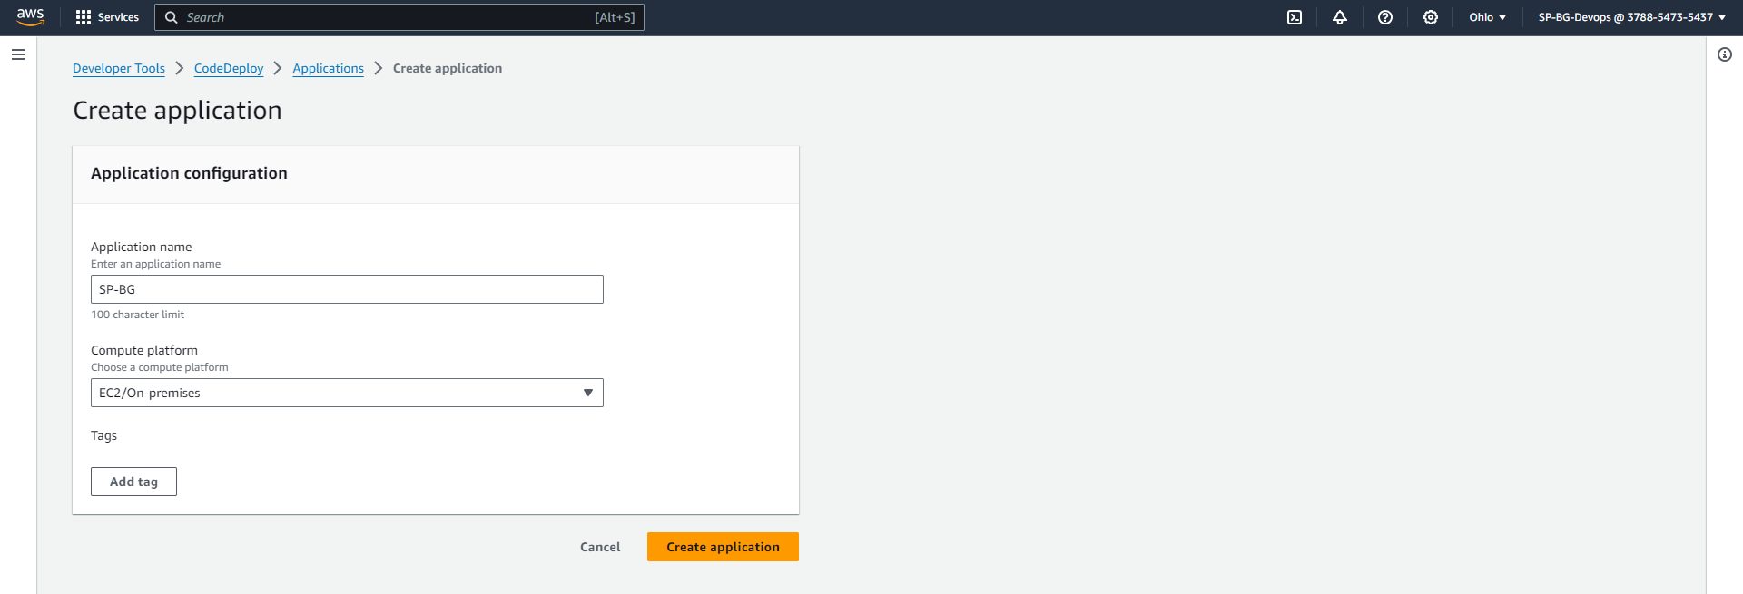

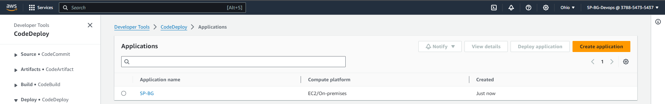

TASK 2: Creating a deployment group for our CodeDeploy Application:

Choose the service role we created for CodeDeploy in Part1. Choose the Deployment type as Blue/Green and Auto-Scaling group we had created in Part1. Choose the ALB we had created in Part1 and create the Deployment Group

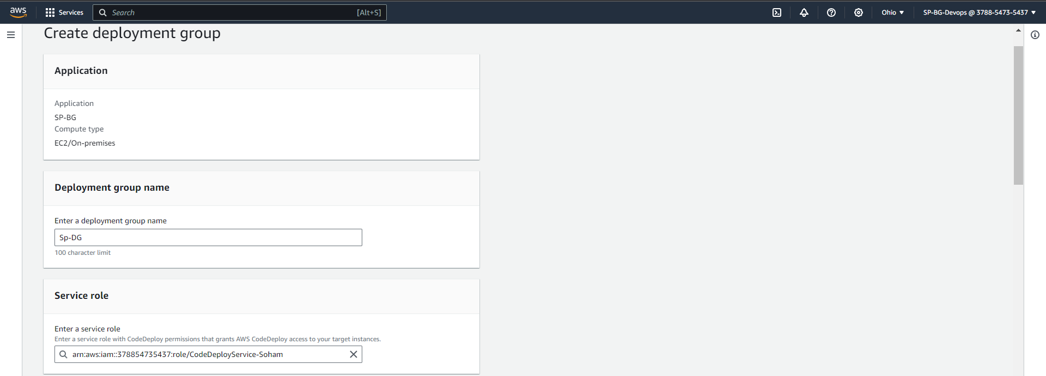

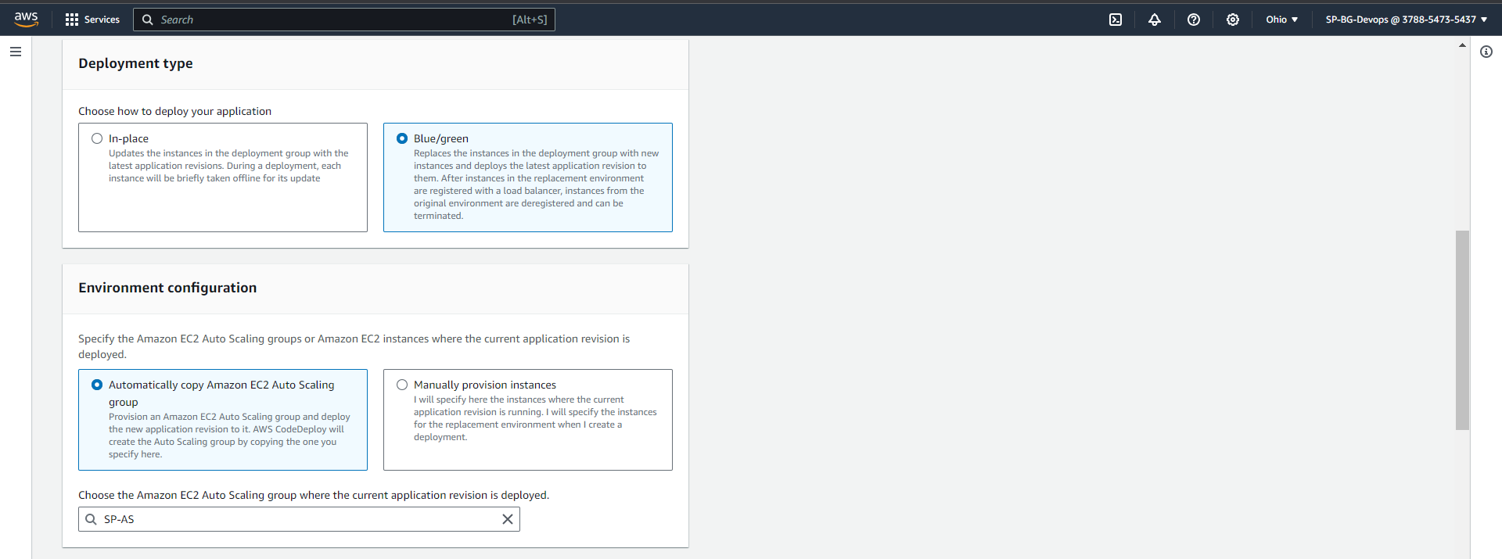

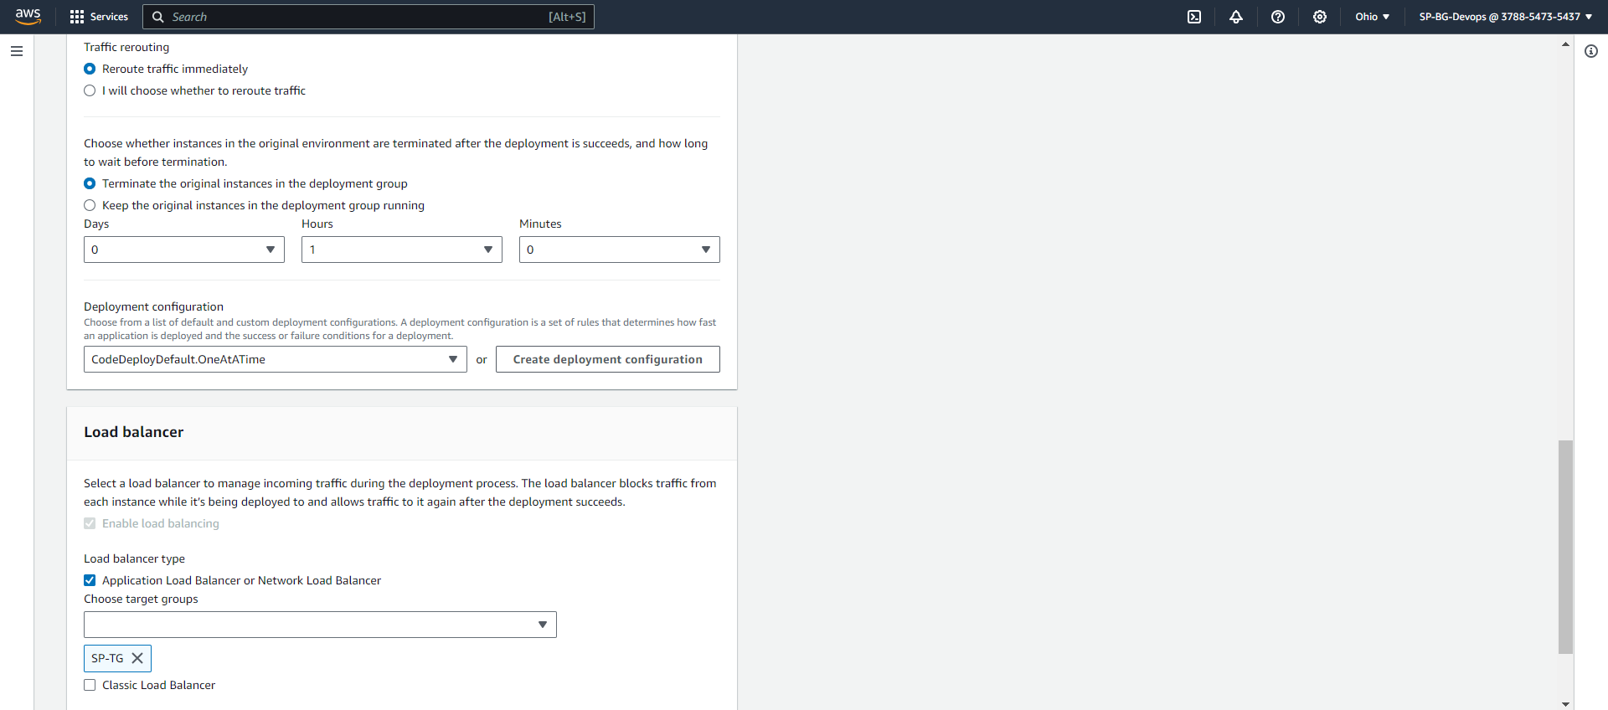

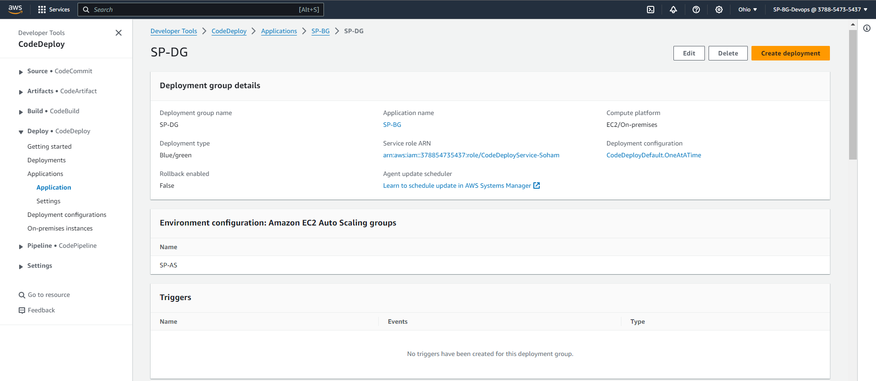

Theory question:

**Q) Explain what is a Deployment Configuration?**

**Ans:** A Deployment Configuration is a predefined set of rules and parameters that govern the management of application updates or deployments in a cloud setting. It provides detailed instructions for tasks like rolling updates and instance termination policies, serving as a guide for the deployment process. Users can tailor deployment strategies to match their application's needs, ensuring a well-controlled and efficient update procedure with minimal disruption.

PART 3: GitHub

TASK 1: Create a new repository on GitHub named as <your-name-BG>

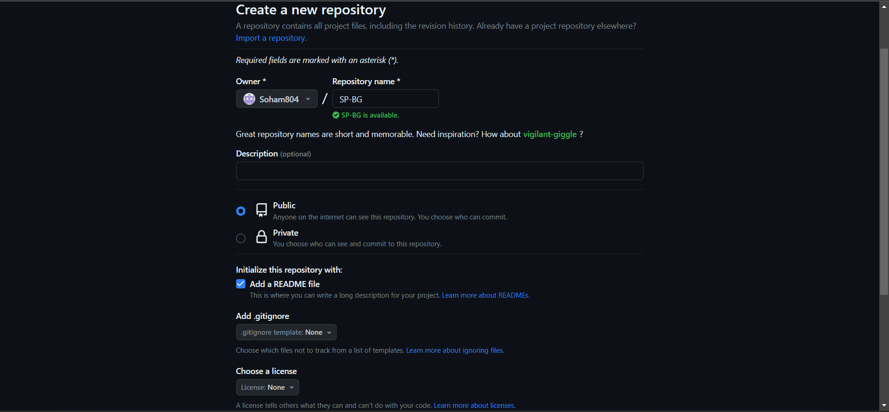

TASK 2: Create a folder in your repo named as scripts and create 3 files in it as following:

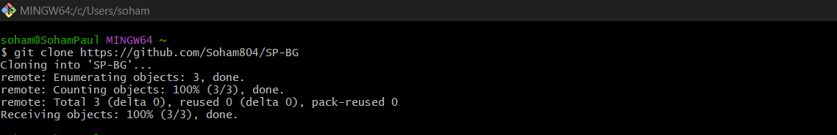

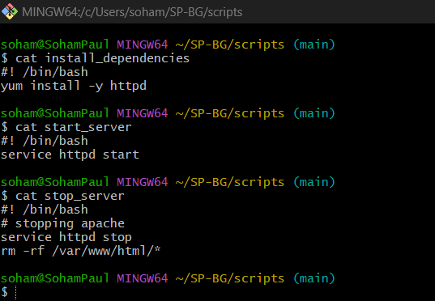

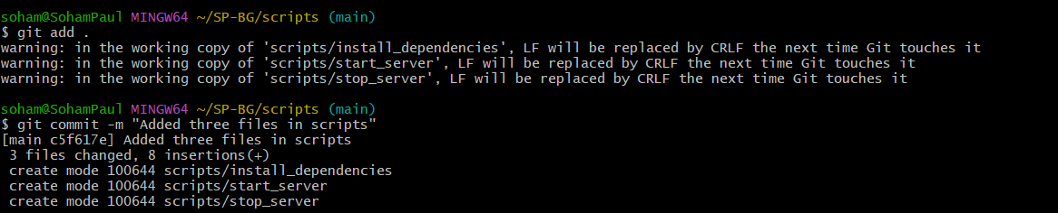

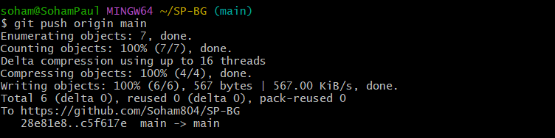

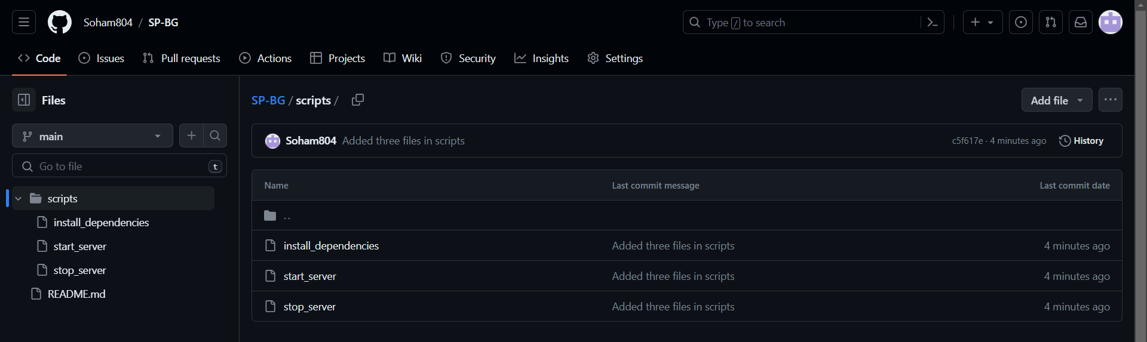

TASK 3: Create an appspec.yaml and index.html file in your repo as following (Not inside the scripts folder)

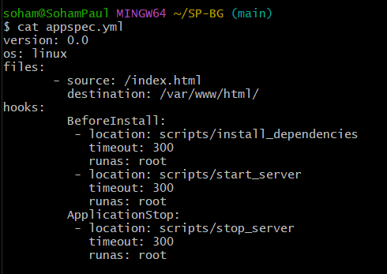

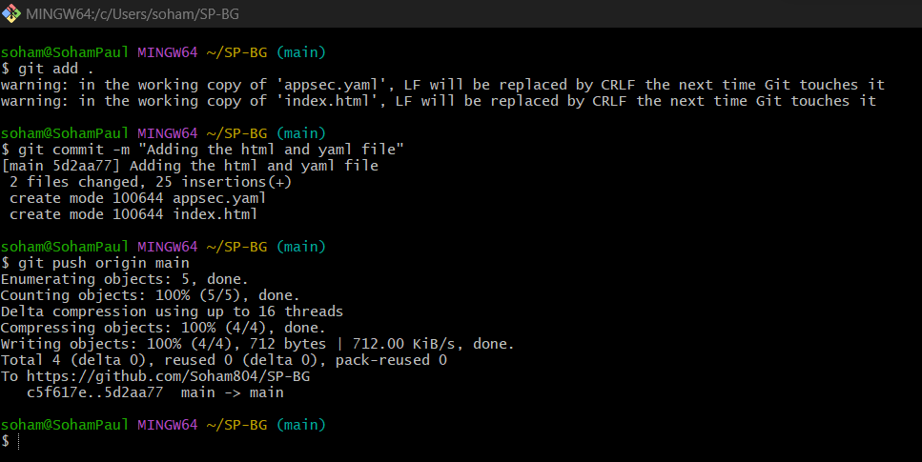

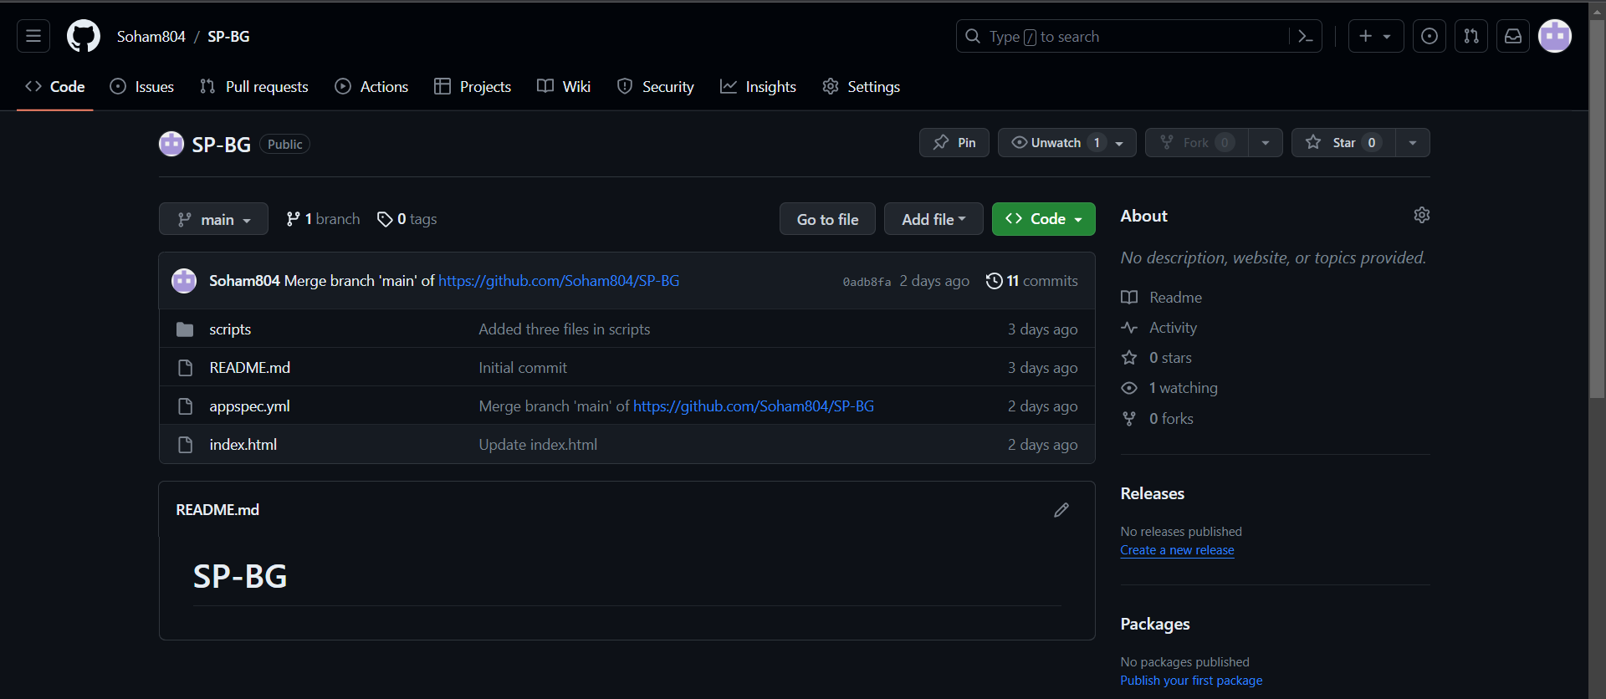

PART 4: JENKINS

Creating Virtual Machine with Ubuntu Desktop

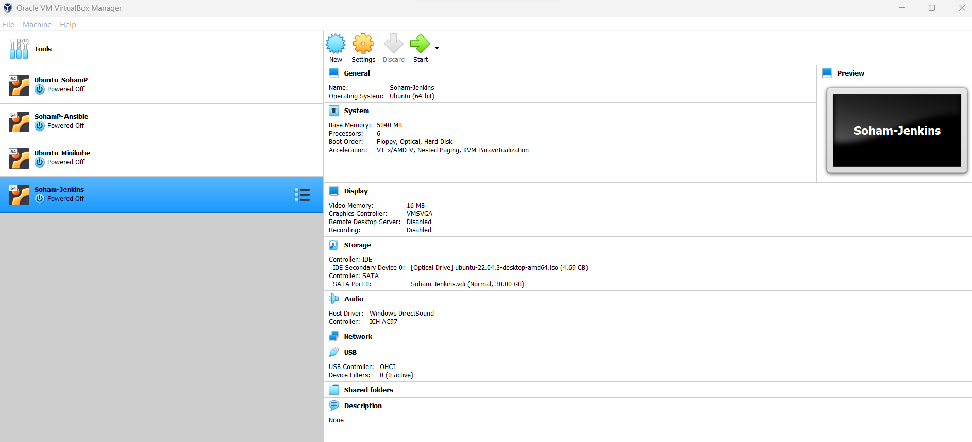

In our lab, we are going to use Jenkins to create our source build and create deployment.

Installation:

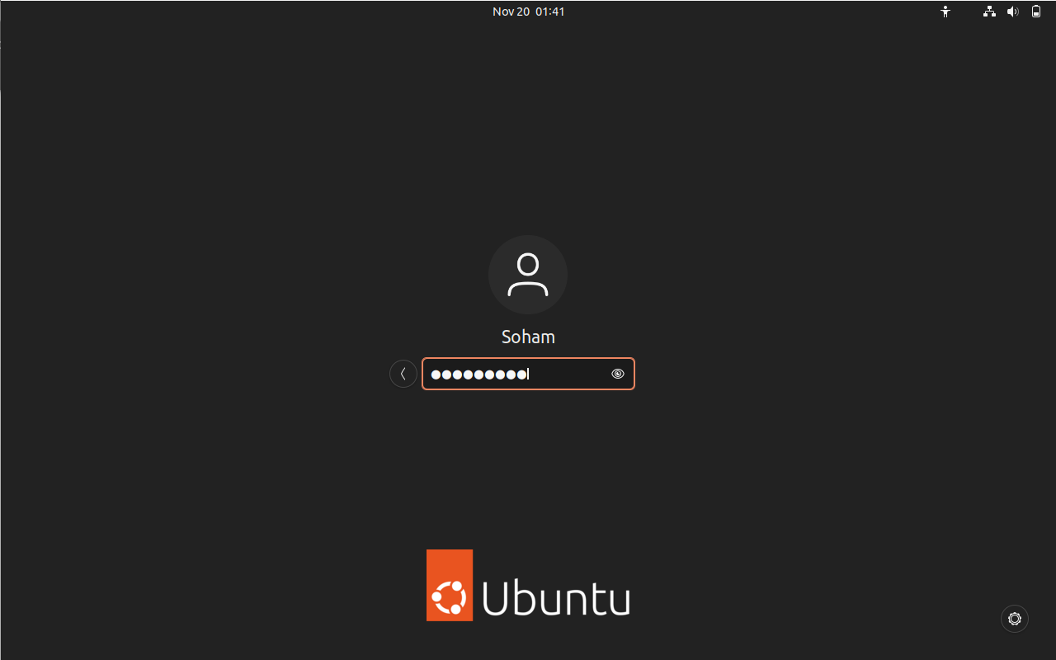

Install Java JDK and Jenkins

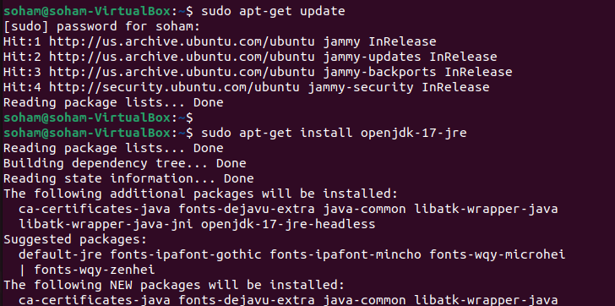

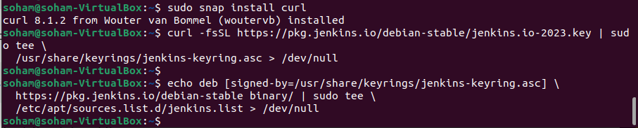

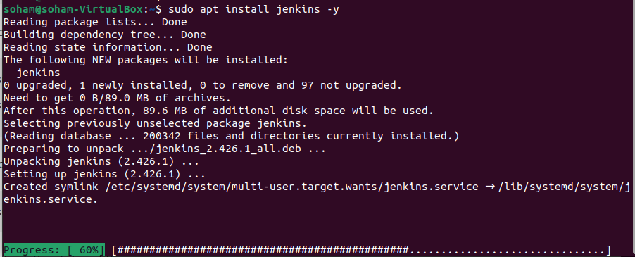

Check Java and Jenkins Version:

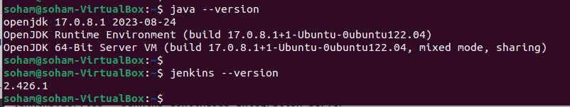

Check Jenkins status:

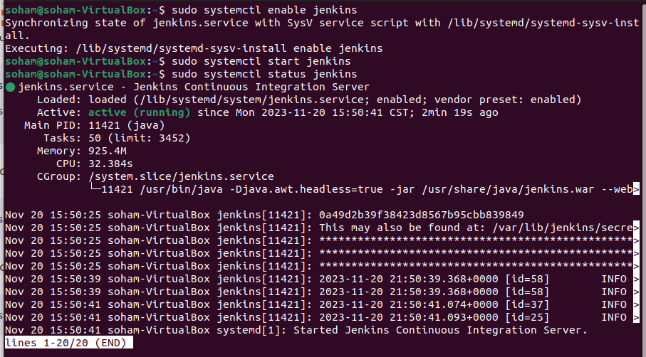

Now go to Browser on same system where Jenkins & java is installed.

Open Jenkins and create a new user of your name, set password & install CodeDeploy Plugin.



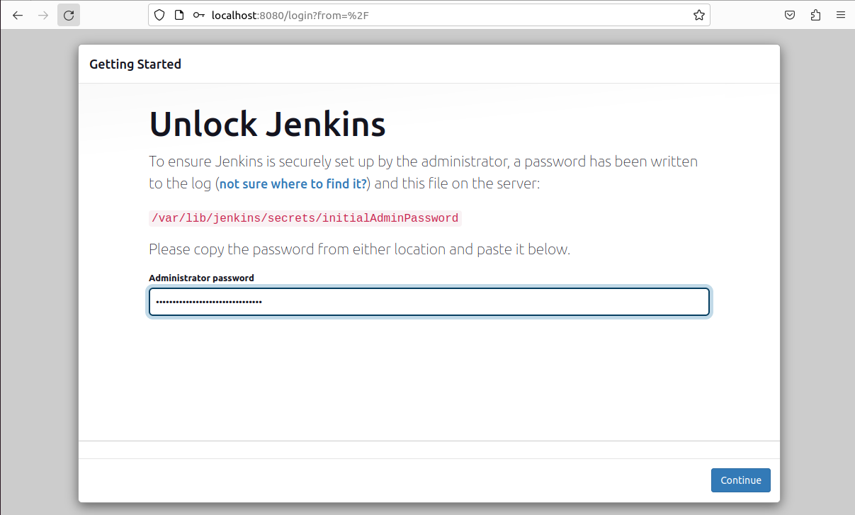

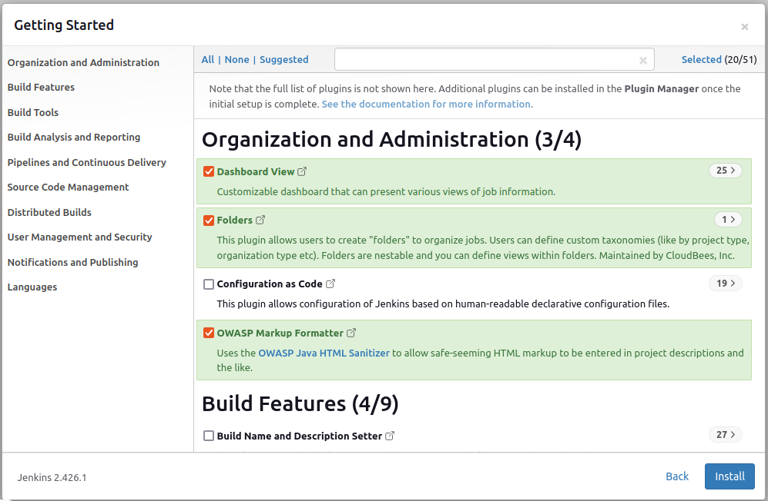

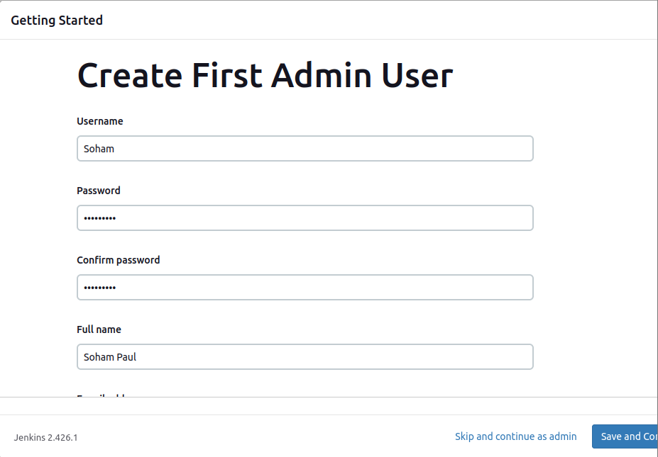

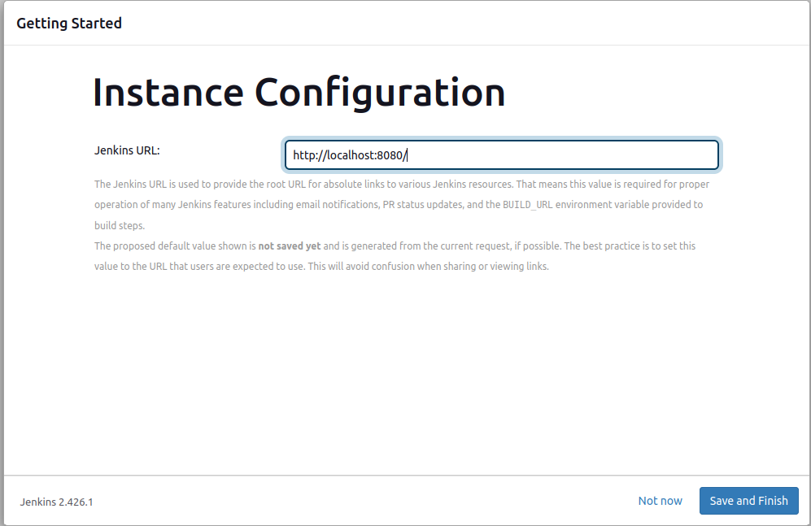

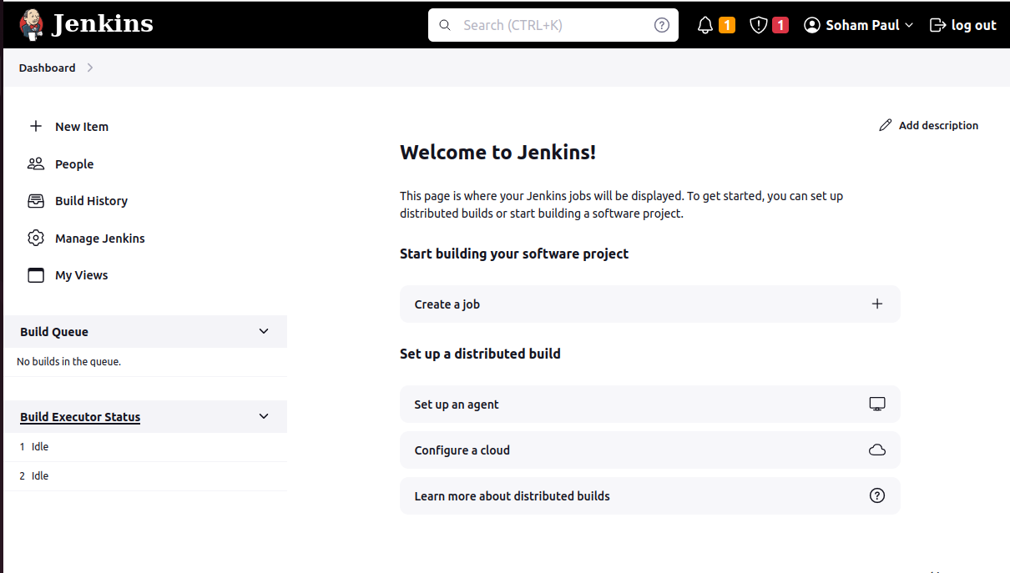

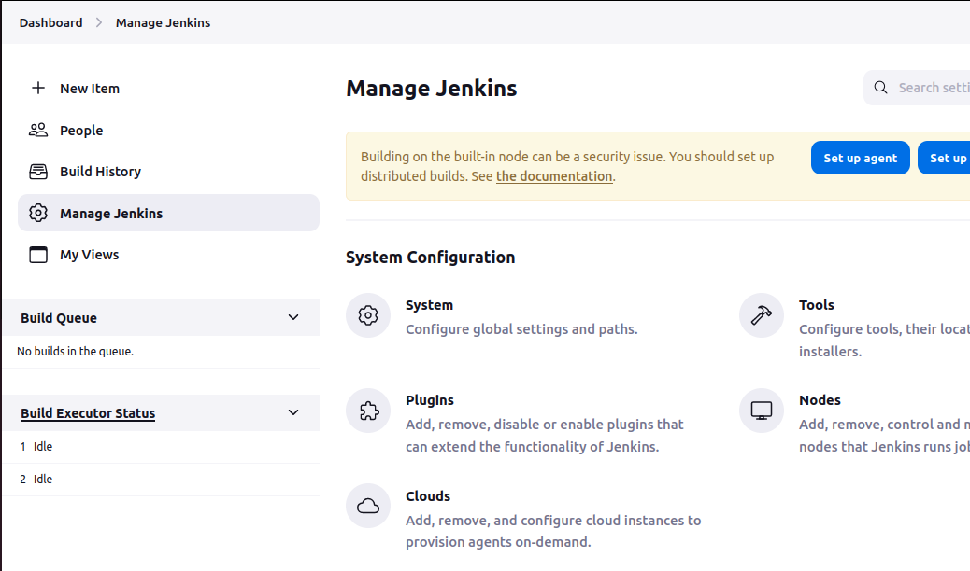

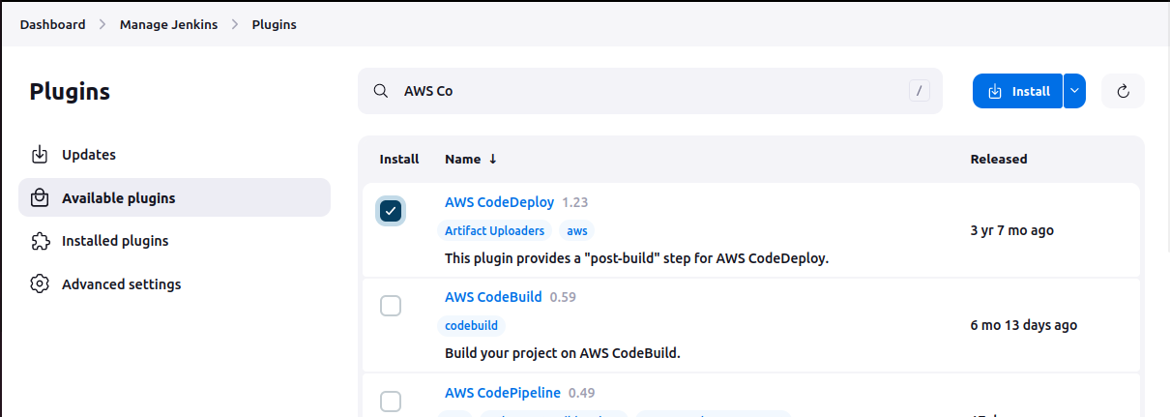

**Explanation of the Steps:** After I installed Java and Jenkins to my Ubuntu system, I will have to unlock the Jenkins to be used for various operations. So, I first found out the initial admin password from my ubuntu terminal and then opened my localhost address to access Jenkins. As this is the first time I am opening Jenkins so I had to provide the initial password found from the initialAdminPassword password file. Then I setup my account by providing my login username and password to access Jenkins from the next time and setup the URL which is by default <http://localhost:8080>. I kept the URL the same, but it can also be changed. After setting up the Jenkins I will be able to access it using the username and password provided by me. Then I went to add the plugins where I added the Dashboard option to manage everything from there. After setting up the Jenkins, then I went to the dashboard and went to manage plugins from where I added the plugin AWS CodeDeploy so that I can deploy code using Jenkins to AWS, which I have done later.

TASK 1: Creating Jenkins job

Step 1: Create a new freestyle Project named as <your-name-BGlab>. Select Source Code as Git and enter your GitHub repo URL. Select a Post-Build job as Deploy application to CodeDeploy and enter the details.

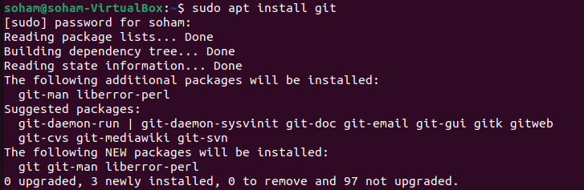

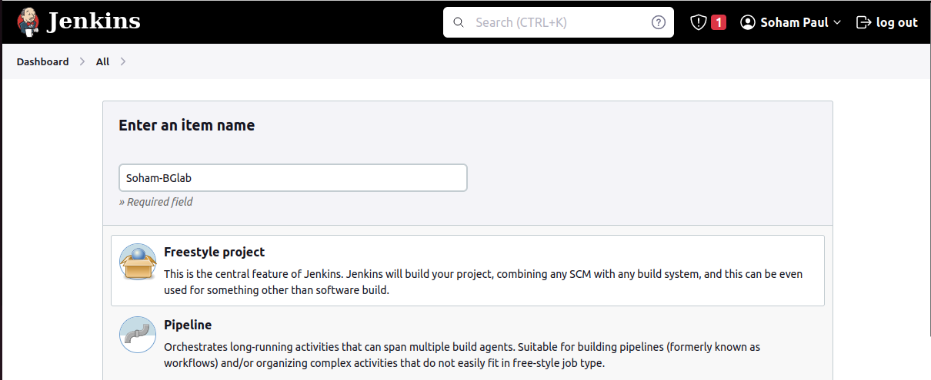

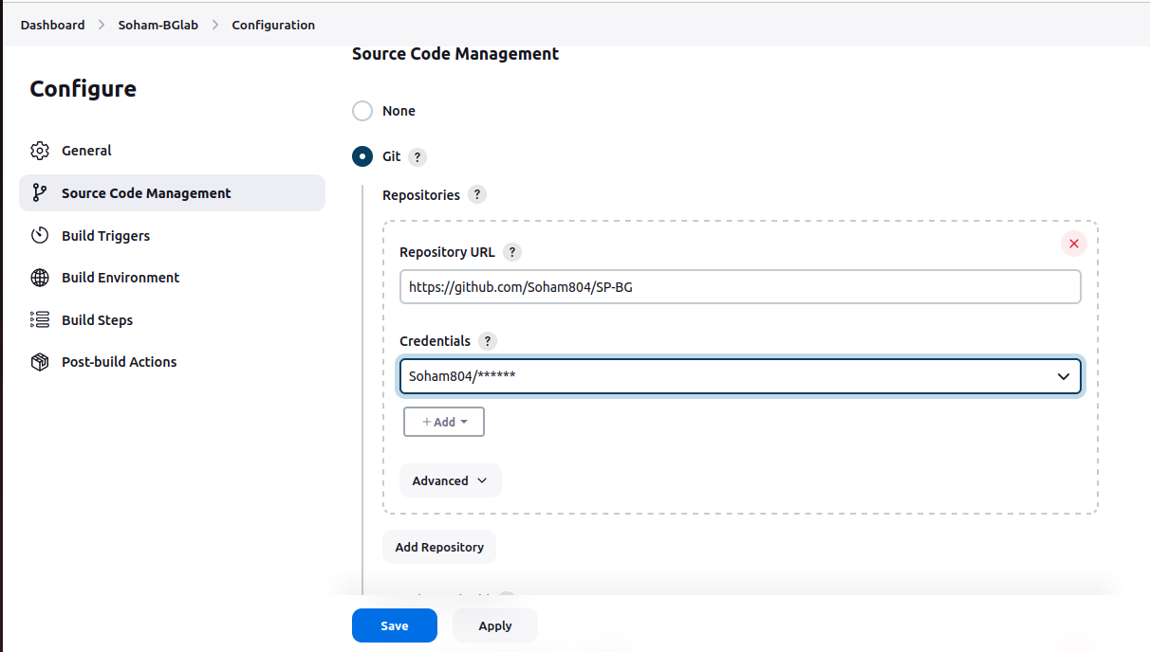

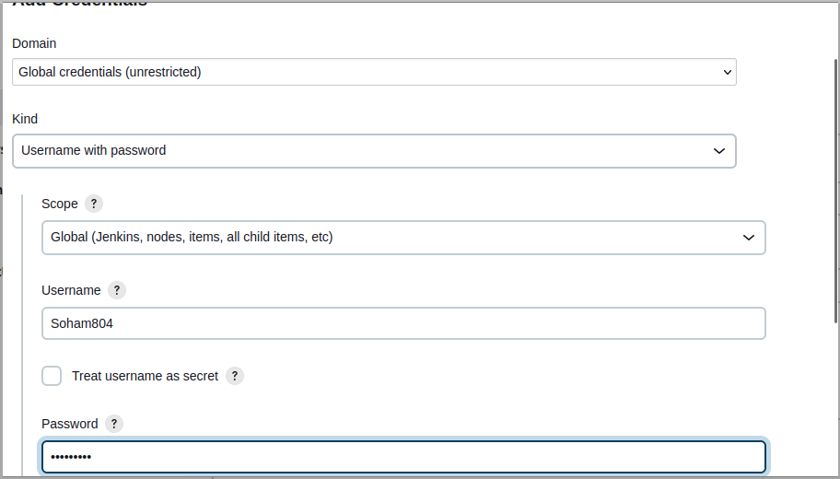

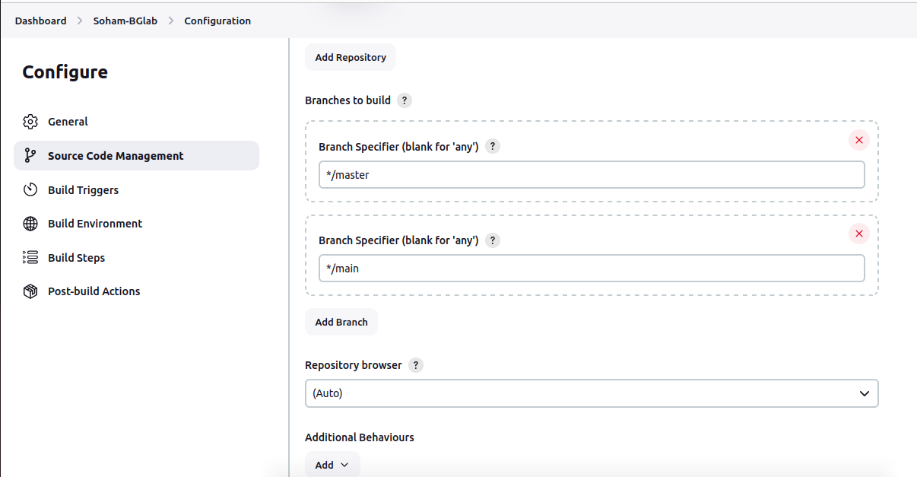

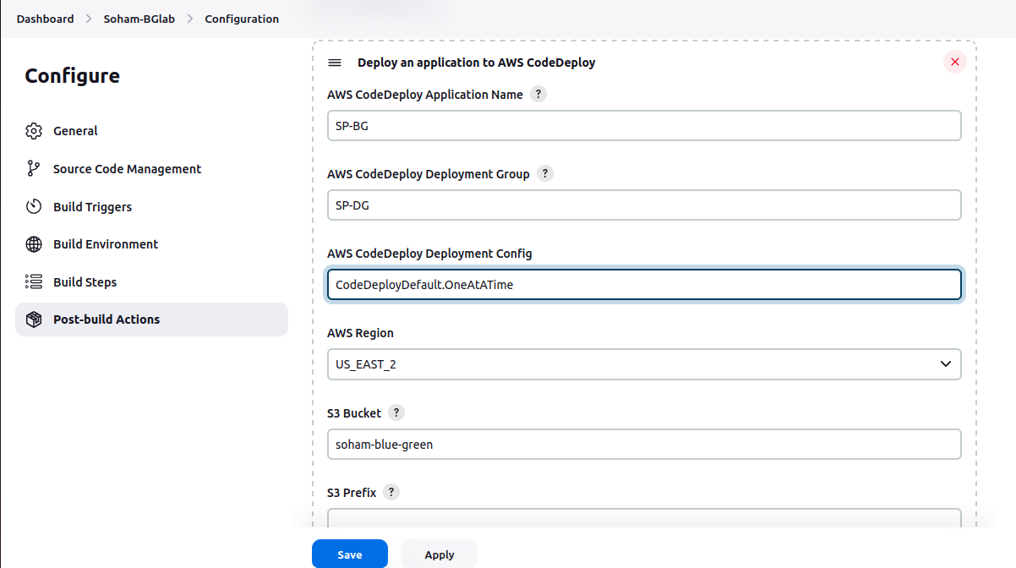

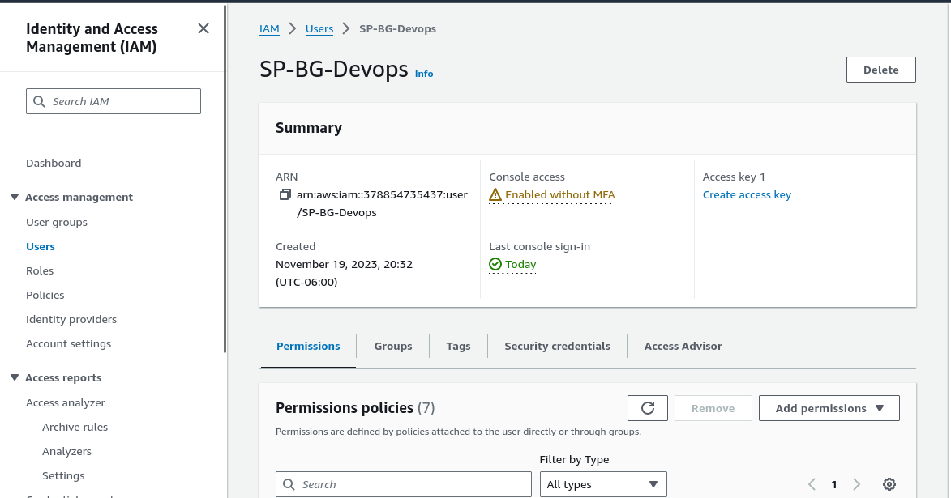

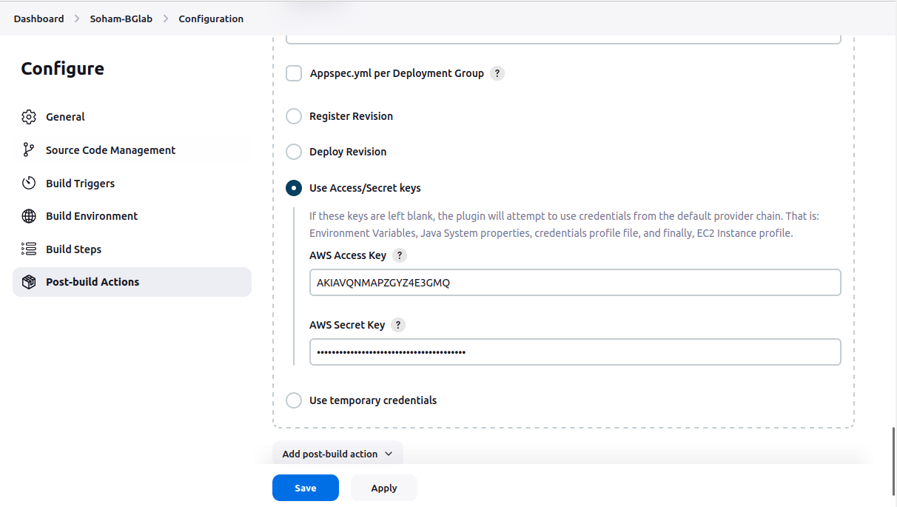

Step 2: Now build your project

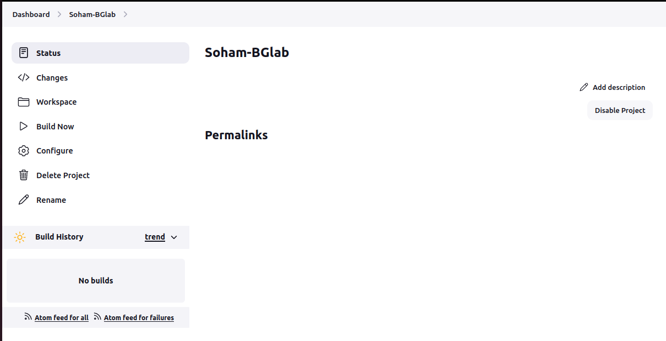

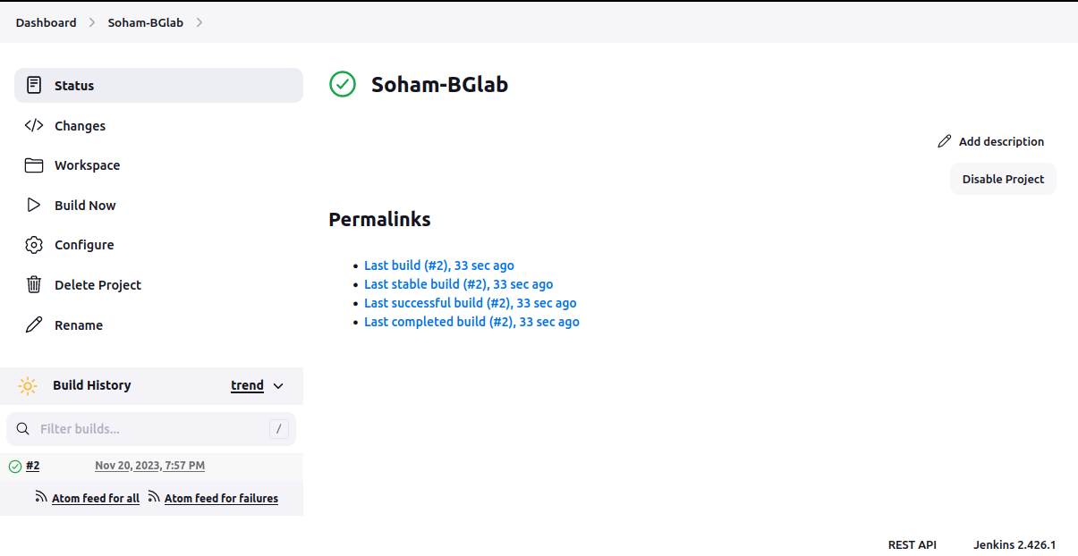

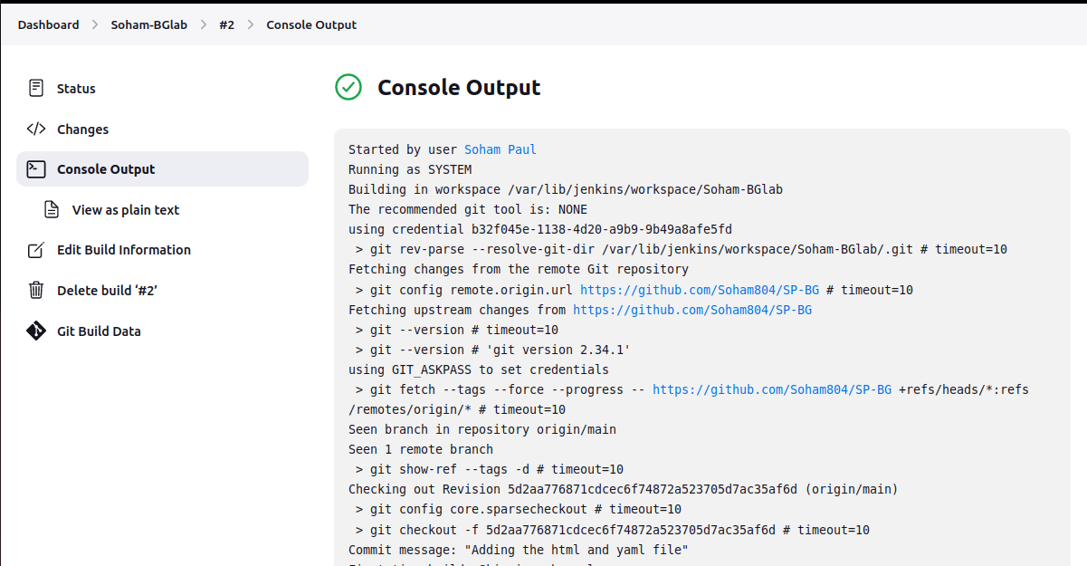

Theory question:

**Q) What is a Jenkins job?**

**Ans:** A Jenkins job is a user-defined task that signifies a specific build, test, or deployment process. It is configured to execute a range of activities like code compilation, test execution, application packaging, and software deployment, Jenkins jobs are customizable to meet project requirements. Users have the flexibility to create, configure, and schedule jobs, each with its own set of specifications, including source code repositories, build triggers, steps, and post-build actions. These jobs are pivotal in automating and coordinating the software development lifecycle, empowering users to define and run workflows in a structured and repeatable fashion.

TASK 4: Now go back to AWS Console and check for the deployment:

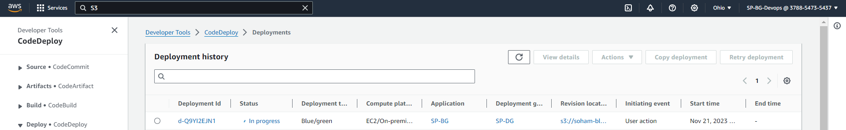

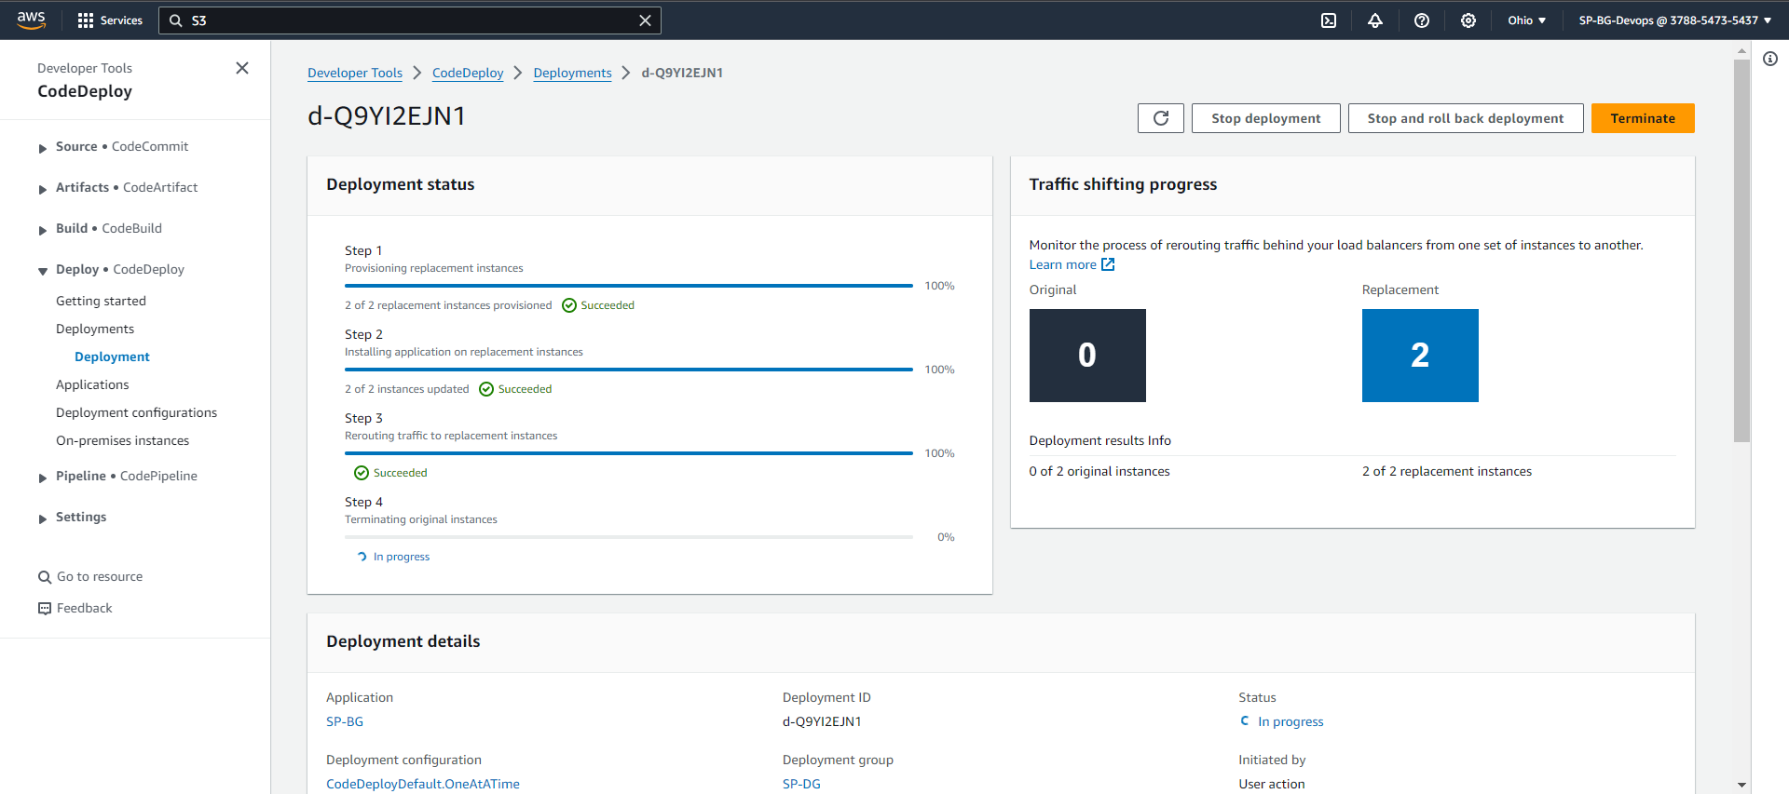

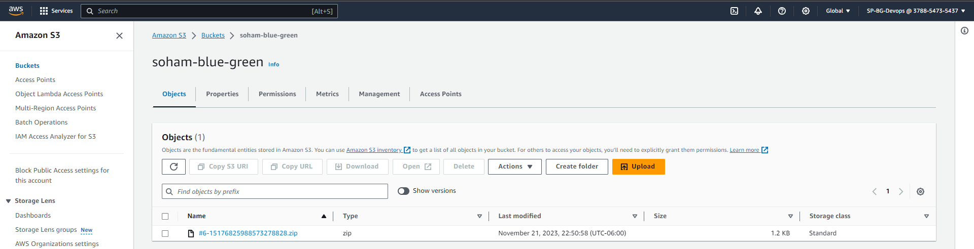

Theory Question:

**Q) Explain the role of load balancer in this scenario**

**Ans:** The load balancer plays a vital role in efficiently and scalably distributing incoming traffic across multiple instances of an application. Jenkins, serving as a continuous integration and continuous deployment (CI/CD) tool, streamlines the automation of code deployment. After the code undergoes building and testing processes, Jenkins can initiate deployment to AWS. In AWS, a load balancer like Elastic Load Balancing (ELB) evenly distributes incoming traffic among multiple instances, improving the application's availability and fault tolerance. This ensures that each instance handles a proportionate workload, optimizing resource usage and preventing any single instance from becoming a bottleneck. This not only enhances the application's performance but also enables seamless scaling by adapting to changes in demand. To sum up, the collaboration between the load balancer in AWS and Jenkins contributes to a dependable and scalable deployment process, effectively managing application traffic and ensuring a seamless user experience.

TASK 5: Check whether traffic has been shifted.

TASK 6: Now when you check all the resource that have been replaced.



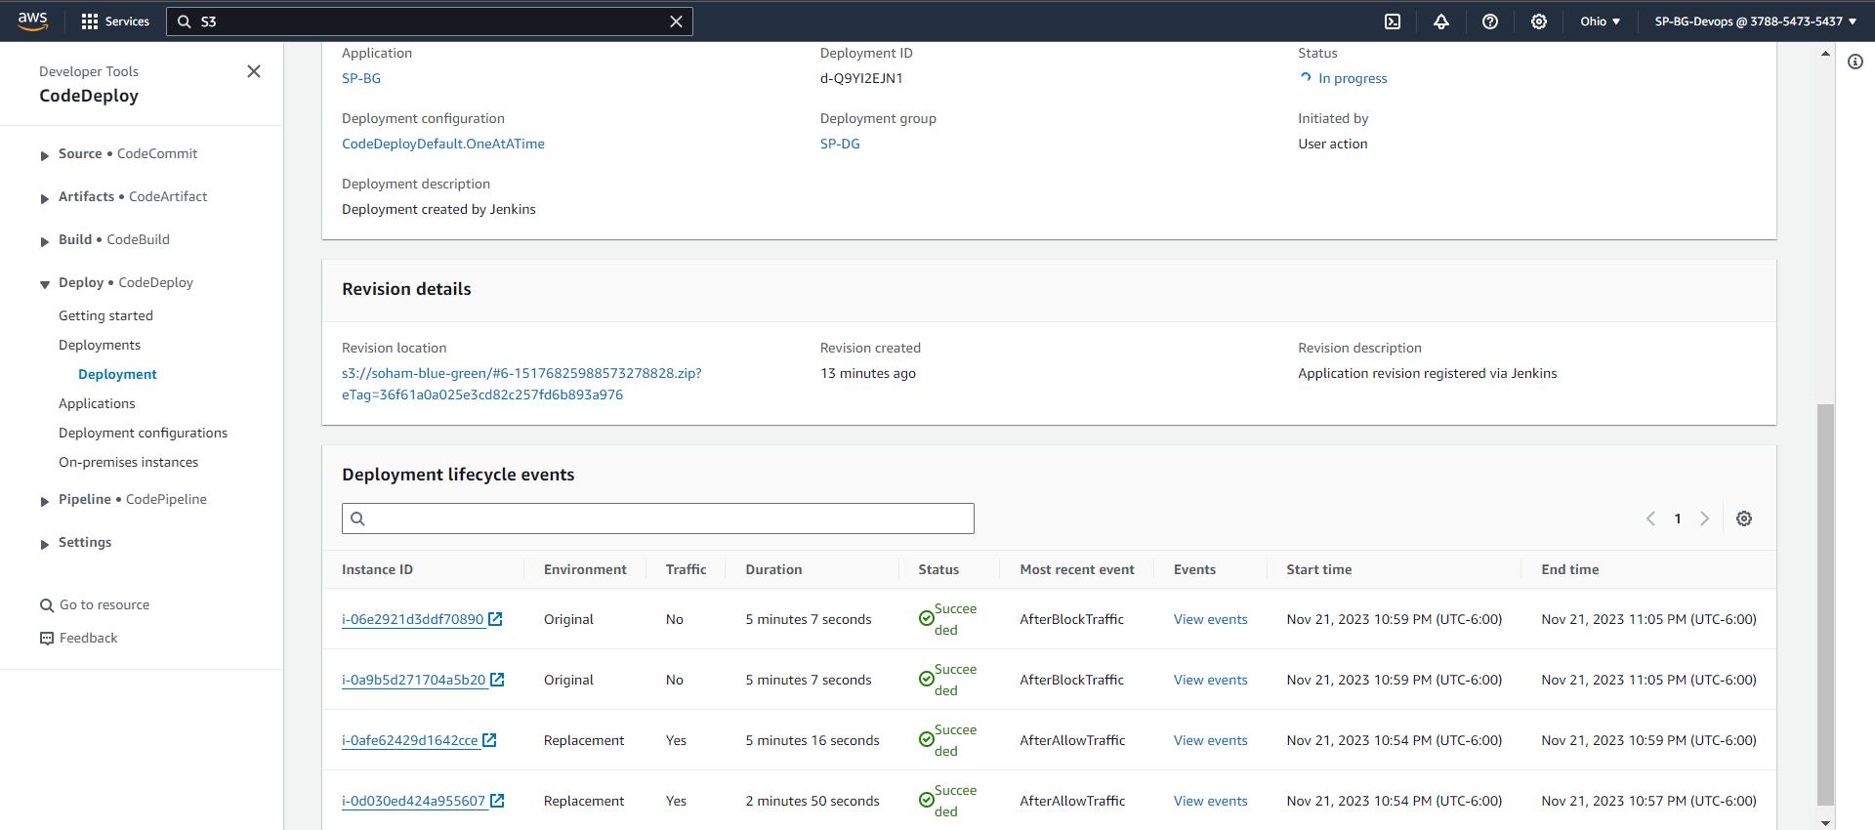

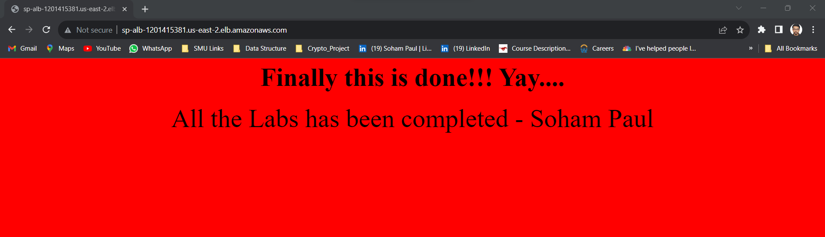

TASK 7: Now make any changes to your index.html file and use Jenkins to trigger it

Updated index.html file:

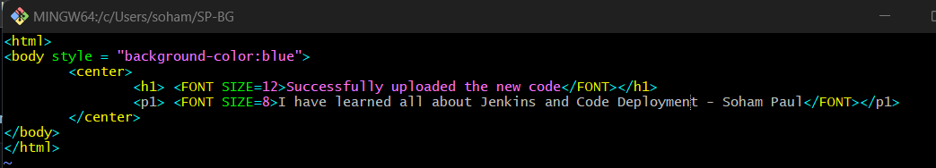

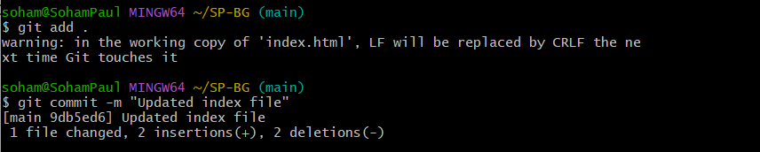

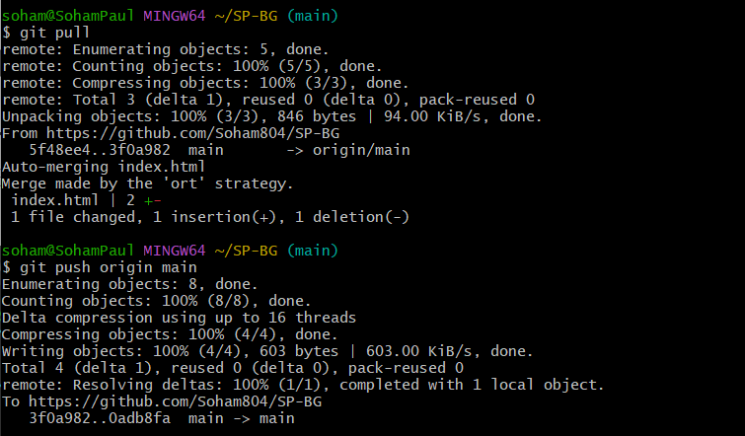

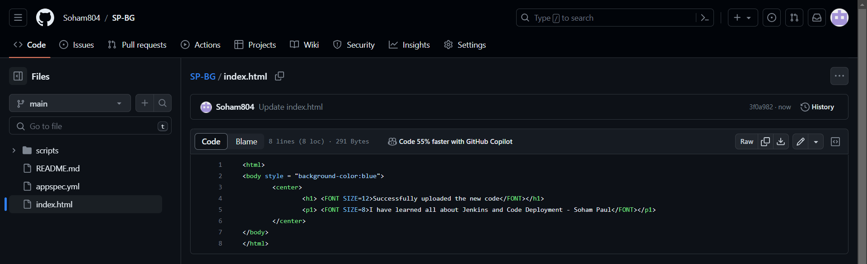

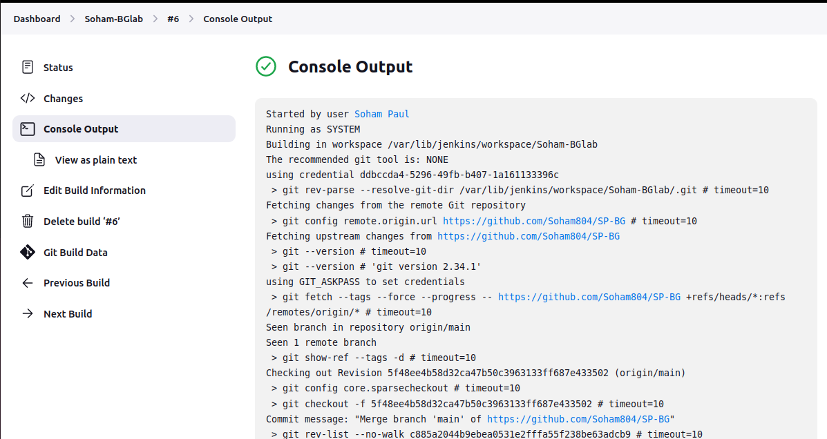

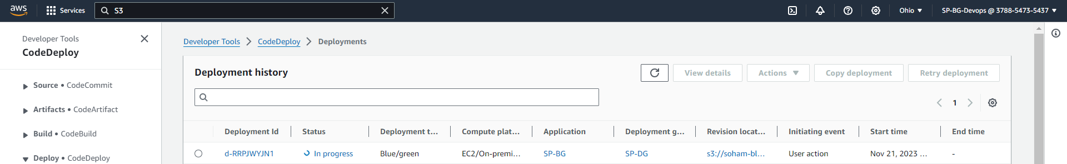

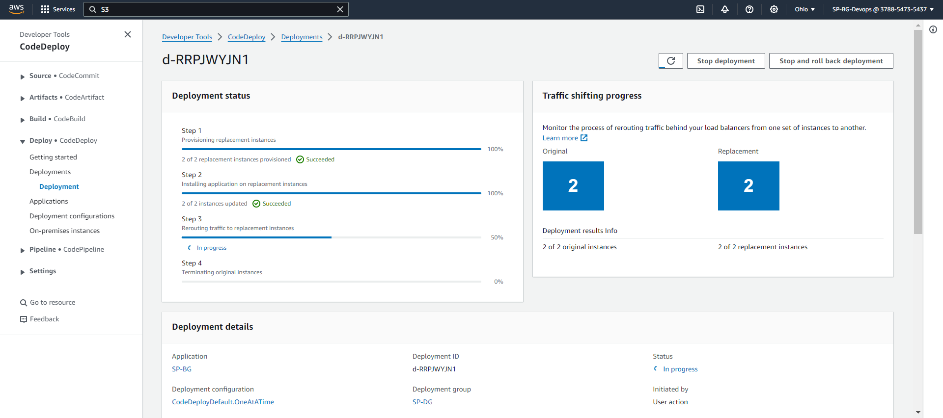

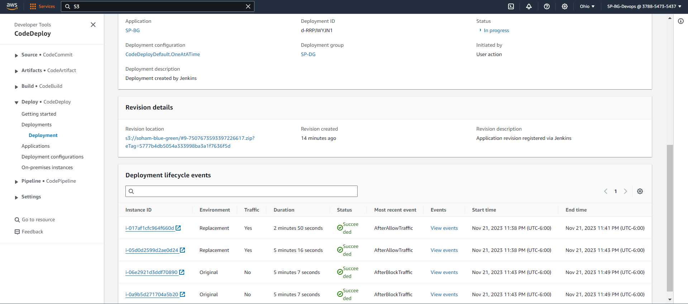

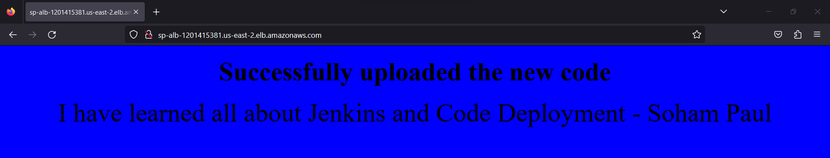

___END OF LAB___